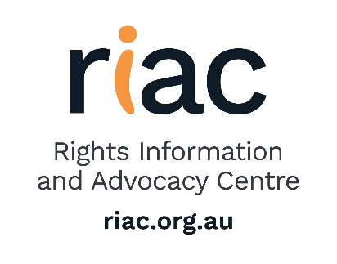
POSITION DESCRIPTION

Title: ORDINARY BOARD MEMBER
Issue date: May 2024

The RIAC Ordinary Board Member has the following responsibilities:

- General
- Governance
- Planning
- Meetings
- Administrative & Management
- Media
- Promotion
- Fundraising
- Legal & Ethical
- Renewal and succession
- Risk Management and Safety
- Meeting and Decisions
- Advocacy
- Develop organisational goals

Responsibilities
General
On being elected to the Board, undertake induction and training procedures as provided by the Board.
Provide strategic direction and leadership.
Recruit, appoint and manage the CEO.
Governance
Consider, discuss and vote on issues before the Board on the basis of the best interests of the organisation only.
Comply with the rules, policies and standing orders of the organisation.
Planning
Review and approve the organisation’s Strategic Plan, and other consequential arrangements (Business Plan, Marketing Plan etc).
Meetings
Attend all meetings, or, if unavoidable, apologise in advance for absence.
Where Board papers are circulated in advance of the meeting, read papers, and consider issues before the meeting.
Contribute to the discussion and resolution of issues at meetings and otherwise as appropriate.
Administrative & Management
Serve on Board committees as required.
Review and approve the organisation’s systems for financial control and risk management.
Undertake administrative duties as required.
Understand the organisation’s finances (including solvency).
Media
Make comments to the media only as provided in the organisation’s Media Policy.
Promotion
Promote the organisation in the community as opportunities arise.
Fundraising
Participate enthusiastically in any fundraising approved by the Board.
Legal & Ethical
Avoid making any improper use of their position in the organisation to gain any material advantage for themselves, or for any other person, to the detriment of the organisation.
Avoid making any improper use of any information acquired by virtue of their position in the organisation to gain any material advantage for themselves, or for any other person, or to the detriment of the organisation.
If they have any direct or indirect material personal interest in any contract with the organisation, inform the Board immediately.
If they have any direct or indirect material personal interest in any contract with the organisation, not vote in the Board on that issue.
If they have any non-material personal conflict of interest in any matter before the Board or believe that the perception of such a conflict might arise, inform the Board immediately and follow the Board’s rulings as to proper procedure.
At all times conduct Board business professionally, politely, objectively and with consideration to others.
Skills and Qualifications
To competently perform in this position, the person should have skills and experience that align with the responsibilities of the RIAC Board and support the RIAC values, respect, independence, action and collaboration.

