How to make a complaint about RIAC
Easy Read

When you see the word ‘we’, it means the Rights Information and Advocacy Service, or RIAC.
 | This guide tells you how to make a complaint if you are not happy with our services.
 | If you asked RIAC for help and are not happy with the help you got or feel you were not treated well, you have a right to complain.
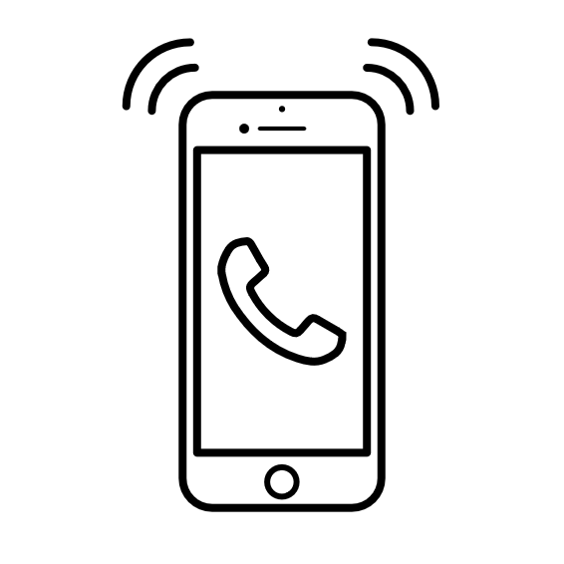 | You can call, write to, or email our complaints person.
 | You can send an email to our complaint’s person at feedbackandcomplaints@riac.org.au
 | You can call or text us on 0491 208 107
 | You can write a letter and send this to PO Box 1763 Shepparton Vic 3630.
 | When we get your complaint, we will have a look at it an make contact with you
 | If you are still not happy with us, you can take your complaint to an outside service who deals with complaints.
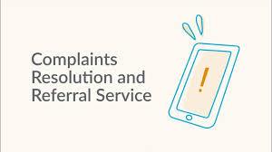 | The Complaints Resolution and Referral Service can help you. You can call them on:  1800 880 052 (toll free).  Let them know that you are not happy with your service from RIAC and that you would like to make a complaint.
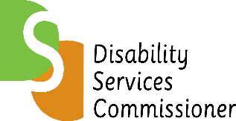 | If you are unhappy with the service provided to you, you can:  Call: 1800 677 342  Visit: Home - Disability Services Commissioner  Referrals can be made to the Disability Services Commissioner (Victoria), an independent body that handles complaints about disability services and promotes the rights of people with disability.
 | You can also make a complaint about any worker to the Victorian Disability Worker Commission.  You can do this by filling out an online form at www.vdwc.vic.gov.au  You can call them on: 1800 497 132  Write to them at GPO Box 181, Melbourne 3001.
 | If you are over 65 years of age and are not happy with your service, you can call the  Aged Care Quality and Safety Complaints line on Call:1800 951 822  Visit: Homepage | Aged Care Quality and Safety Commission  Write to:  Aged Care Quality and Safety Commission  GPO Box 9819, in your capital city
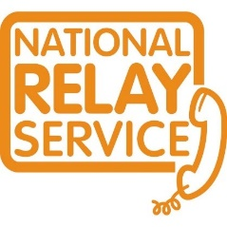 | Callers who are deaf or have a hearing or speech impairment can contact the  National Relay Service (NRS)  Call: 1800 555 677 then asking for 1800 880 052
 | If you do not speak English, you can use the Translating and Interpreting Service (TIS)  Call: 13 14 50

