Privacy Policy
Easy Read

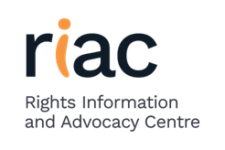 | The Rights Information and Advocacy Centre (RIAC) knows how important privacy is. We are committed to protecting your personal information.
 | This Privacy Policy relates to everything you do with RIAC.
When you sign the RIAC consent form you agree to this policy every time you:
 | Use the RIAC website
 | Write, Phone or email RIAC
  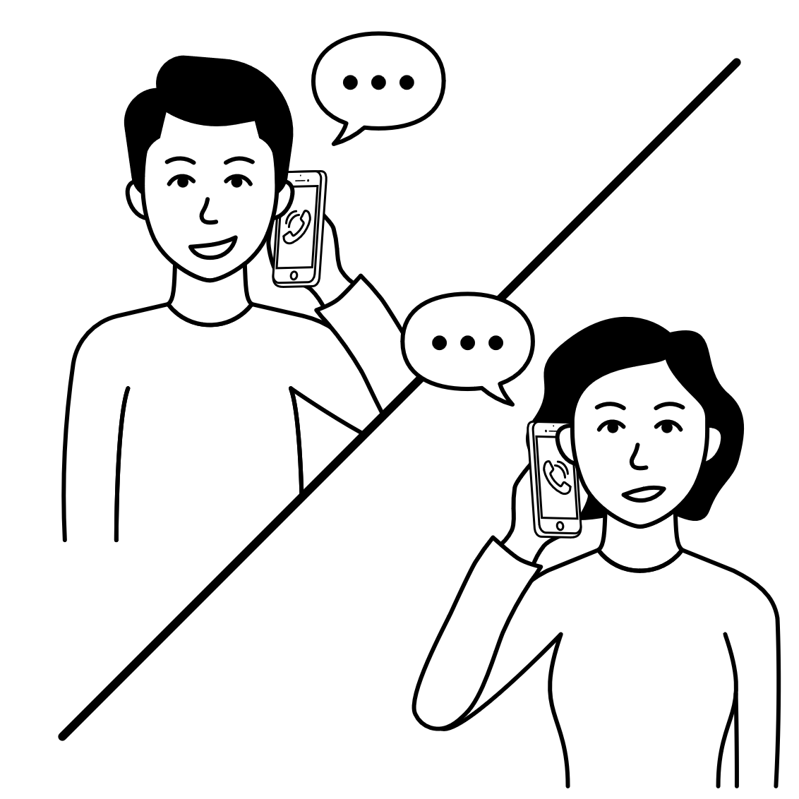 | Talk to a RIAC staff member
How does RIAC use your personal information?
 | To get to know you  To assist you to with supporting and helping you  To decide if RIAC is doing a good job or if we could do better
 | Sometimes, RIAC is asked to give some information to our funding bodies and participate in program audits.  We will get your consent before we do this.
Where Does RIAC Store Your Personal Information?
 | All information is locked away.  All computers have passwords to protect your information  All information is stored electronically in Australia
When Does RIAC Share your Personal Information?
 | When we need to talk to someone about what you have asked us to help you with.  When someone wants to check that RIAC are doing things right.  If we believe you are at risk of harm to yourself or others  As required by law
How Does RIAC Ensure Your Personal Information Is Correct?
 | Personal information will only be collected with your consent  You can help us by letting us know if there are any changes or something is wrong  RIAC will ask you from time to time
Breach of Confidentiality
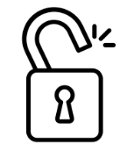 | A breach of confidentiality is when your private information is shared with anyone verbally, online, physically or in any other way without your consent.  RIAC has policies and procedures in place to make sure this does not happen and takes it very seriously if it does.
How Can You Access Your Personal Information Collected By RIAC?
  ceo@riac.org.au | You can ask to look at your information at any time by emailing the CEO.
Making a Privacy Complaint
 | Your privacy is important.  If don’t like the way RIAC has used your personal information, please:  Think about what you want to RIAC to do differently  Call RIAC on: (03) 5222 5499  RIAC will try and fix the problem as quickly as possible  If you don’t think that RIAC has fixed the problem, you can:  Talk to the RIAC Business Systems Manager  Call: 0491 208 107  Email: feedbackandcomplaints@riac.org.au  Contact the Complaints Resolution & Referral Service  Call: 1800 880 052.  If you would like a copy of RIAC’s complete Information Privacy and Data Protection Policy, you can contact a RIAC staff member or find this on our website at www.riac.org.au

