**2024 ANNUAL REPORT**



RIGHTS INFORMATION AND ADVOCACY CENTRE INCORPORATED (RIAC)

ACKNOWLEDGEMENT OF COUNTRY

##### Rights Information and Advocacy Centre acknowledge and pay their respects to the traditional owners of the land on which we are present, and to their elders past, present, and emerging.

We acknowledge that this land has never been ceded, and was and always will be, Aboriginal land.

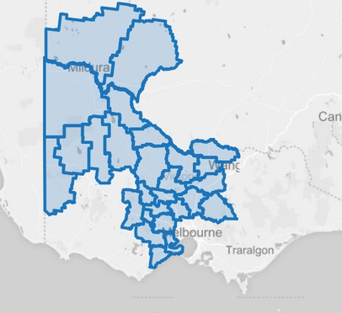



To amplify the voice of people in our communities to drive individual and systemic change and achieve social justice.

**OUR MISSION**

**OUR VALUES**

Respect for human rights Independent

Action with purpose Collaboration for impact

An inclusive and accessible society for all.

**OUR VISION**

## THE RIAC LOGO OVER THE YEARS

1984



2015



2024

 2004



 2016

In February 2024, RIAC changed its logo. This report contains photos from before and after this change.

## FROM THE CHAIR



Thank you for your continued trust and support.

Carli Leishman

Chair, RIAC

I am pleased to present the Rights Information and Advocacy Centre's Annual Report for 2023/2024.

This year has been one of great progress, growth, and resilience, thanks to our strong commitment to supporting the rights of those we serve.

Our biggest achievement was merging with the Barwon Disability Resource Council (BDRC), which strengthens our ability to provide advocacy services to people with disabilities and their carers across more of western Victoria. This move expands our reach and ensures more people can access the support they need. We were also excited to welcome Dianne Thompson and Ainslee Hooper to the RIAC Board.

We finalised our Strategic Plan for 2024-2028, focusing on three main goals: to innovate collaboratively to better serve our communities, becoming a leading voice in our sector, and building our organisational sustainability and resilience.

This year, the Board expanded our sub-committees, welcoming Belinda Franklin to the Finance and Audit Committee. We also established the Lived Experience Advisory Committee (LEAC), which has already begun meeting, and we look forward to their valuable input.

I want to thank my fellow board members, our CEO Dr. Sandy Ross, our executive team, staff, and volunteers. Together, we are making a real difference, and I look forward to what we can achieve next year.

## MESSAGE FROM OUR CEO

##### Reflecting on my first full year working at RIAC, while we have been through a lot of change, we have maintained as a constant our strong focus on supporting and empowering clients and their communities through our Advocacy and Access & Support programs. Other parts of this Annual Report tell the story of RIAC in terms of data and case studies and program descriptions; in these comments I want to recognise some of the key events and issues impacting on RIAC and the communities we serve.

In late 2023 the Disability Royal Commission (DRC) issued its final report with 222 recommendations identifying the changes Australia needs to make to better recognise and support the human rights of people with disability. The voices and experiences of people with disability lay at the heart of the DRC’s findings, reflecting the witnesses the Commissioners had heard from, and the courage, strength and resilience of the disability community participating in the Commission’s proceedings. As part of enabling this, while the DRC was in progress RIAC was one of many organisations that ran a program assisting and supporting people to participate in the Commission processes.

Alongside the DRC handing down its report, in late 2023 the NDIS Review also issued its final report, which has flowed through to processes still underway to reform the NDIS and also institute at State Government level greater responsibility for basic services and supports for people with disability - so-called Foundational Supports. Amongst all the DRC and NDIS Review recommendations, and the generally limited and disappointing responses from Governments so far, the important role of RIAC and other disability advocacy organisations has shone through, with the DRC recommending increased funding for disability advocacy.

Due to cessation of funding streams, increased compliance costs and funding not keeping pace with inflation, sadly RIAC was forced to lose two advocacy positions in May 2024. Many other disability advocacy organisations have lost even more than that. Reflecting this difficult environment, the Barwon Disability Resource Council (BDRC) identified a challenge it faced in trying to keep its doors open with inadequate funding, and spoke with RIAC about joining the two organisations together. The shared sense of mission between the two organisations made the merger that eventuated in May 2024 something that genuinely benefited the communities both organisations serve, making for a stronger advocacy presence in Geelong, and a stronger more diverse Board and staff for RIAC.



Cheif Executive Officer

Other noteworthy developments in the year include RIAC’s adoption of an Outcomes Framework, designed to help us evaluate and show the impacts of RIAC’s work, both for individual clients and the wider community; the development and updating of policies and systems improving our consistency and accountability of operations across risk, finances, staff health and safety; reorganising our management structures, renewing our brand/logo and establishing a new Lived Experience Advisory Committee to support RIAC’s Board and management.

In June 2024, our accreditation under the National Standards for Disability Services was renewed, with really positive feedback from our clients coming to the independent auditors. This reflects the dedication and professionalism of our advocacy staff (matched by our wonderful Access and Support staff as well, it should be said). My thanks are due to the many people who make RIAC such a good organisation that I am privileged to lead. Many thanks to the RIAC staff for being a great bunch of people focused on empowering clients and building community, and considerate and supportive also with each other (and me!). Thanks also to our InForm Hub volunteers during the year, Sherrie (Bendigo) and Marg (Mildura) who have made such valuable contributions as well.

Lastly, I want to thank the RIAC Board members, who volunteer a lot of their time and assume significant responsibilities for RIAC’s governance. The Board members draw generously on their expert skills, knowledge and life experience in their role, guided by a focus on making RIAC an effective organisation able to achieve its mission.



Dr Sandy Ross

# BARWON DISABILITY RESOURCE CENTRE MERGER

2023 was a very difficult year for the BDRC as, due to insufficient funding for advocacy and the loss of funding for other programs, it became apparent that we would not be able to continue to operate in a sustainable way without significant staffing cuts.

The BDRC Board agreed that all decisions they made about the future of the BDRC would be guided by the principle of protecting and maintaining advocacy for people with a disability in the Geelong and Barwon Region. Consequently, after much discussion, this led to the decision to seek a merger with another advocacy organisation. We identified RIAC as the obvious partner for this given that they were an advocacy service already operating in Geelong.

From that point on the process went remarkably well due to the willingness of both the BDRC and RIAC Boards to negotiate in good faith. We are also very grateful to the RIAC CEO, Dr Sandy Ross for his openness and for his compassion, empathy and understanding of the difficult process we were going through after 49 years of service to the Geelong and Barwon community.

I would also like to acknowledge the support I personally got from the BDRC Board and staff during this period and I thank them for their kindness and wisdom. The merger with RIAC was formally completed on 20 May 2024 and we look forward to continuing to serve our local communities long into the future.

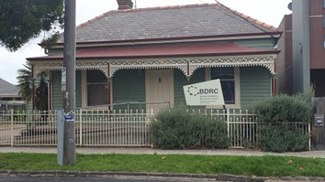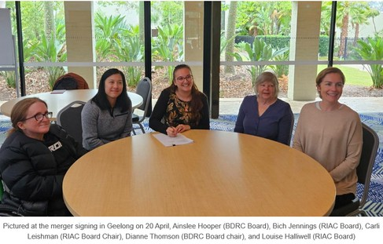

David Petherick Executive Officer

Barwon Disability Resource Council

# STATISTICS

**O V E R T H E C O U R S E O F T H E Y E A R , R I A C S U P P O R T E D V A R I O U S M A T T E R S A C R O S S A L L O F O U R P R O G R A M S .**

**D I S A B I L I T Y A D V O C A C Y**

**383**

**CASES**

**N D I S A P P E A L S**

**N A T I O N A L D I SA B I L I T Y**

**I N SU R A N C E SC H E M E A P P E A L S**

**46**

**APPEALS**

**W O R K I N G W I T H V O L U N T E E R S**

**1449**

**HOURS**

**C O M M O N W E A L T H H O M E S U P P O R T P R O G R A M**

**1219**

**HOURS**

**H O M E A N D C O M M U N I T Y C A R E P R O G R A M**

**3199**

**HOURS**

## NDIS APPEALS

##### The NDIS Appeals program during the 2023/2024 period was at capacity and beyond for most of this time. Requests for NDIS appeals advocacy support were triaged by the intake team based on urgency, lack of formal and informal supports and the type of appeal (Access v Reasonable and Necessary supports) with priority given to access requests for clients with no family or formal support.



Advocates were working at capacity and demand on RIAC services continued to be very high, leading to the decision to close intake to appeals cases and offer only one hour, ‘once-off’ support appointments to clients. Clients were provided with advice around the appeals process, including what to expect during case conferences and general information on how to maximise their prospects of success at the Tribunal.

This support proved to be beneficial to some, but often also left clients feeling uncertain that they could manage through the process alone, given its complexities and intimidating legalistic nature. Unfortunately, the decision was made to offer only this limited support to appeals clients as our service was not able to keep up with demand from these vulnerable community members who were navigating the External review process.

“I felt like the whole world had let me down. RIAC helped me to get my independence and confidence back.” - NDIS client

## NDIS APPEALS CASE STUDY

A client sought support from RIAC with her external review application to the Administrative Appeals Application (AAT) for access to the NDIS. The client lives with both physical and psychosocial impairments. She required support as she found the process complex, overwhelming and stressful.

The client lives with her husband, who is also her carer. He is also a participant on the scheme, receiving supports for his psychosocial impairments. He was therefore only able to provide her with very limited support during the appeal process.

RIAC were able to provide the client with intensive support over the past 5 months, assisting by acting on her behalf in all communications with the Tribunal, the NDIA lawyer with carriage of the matter, case manager and treating medical practitioners to gather the evidence needed to meet the legislative requirements for eligibility.

Some aspects of the matter proved to be challenging, with for example, some medical practitioners being hesitant to become involved and provide the supporting evidence requested of them.

Overall however, the process went well, and we were able to achieve a fantastic outcome for the client with her application being successful, and the NDIA offering her access to the scheme.

We credit the success to RIAC’s diligent and proactive support during all aspects of the External review process. The client will now receive the support she requires to enable her to live as fulfilling a life as possible.

### FIRST NATIONS DISABILITY ADVOCACY PROGRAM (FNDAP)

RIAC provides specialised assistance for First Nations people with a disability living on Wadawurrung, Taungurung, Bangerang, Yorta Yorta, Ladji Ladji, Barkindji, Dja Dja Wurrung and Ngurai-illam Wurrung Country.

RIAC focuses on empowering First Nations people to live independently and with dignity. We have dedicated First Nations Advocates to support individuals and families. All our staff undergo comprehensive cultural awareness and safety training, ensuring a deep understanding of the contemporary challenges faced by First Nations people with disabilities, especially those who have experienced trauma. Our approach is tailored to provide the best possible support, addressing complex issues within their communities with sensitivity and expertise.

We assist in amplifying individual voices, helping with self-advocacy, letter writing, and navigating complex government systems like NDIS, Centrelink, Aged Care, Housing, Legal, and Education.

Our expertise includes guiding individuals to understand and connect with other agencies or services.

RIAC also advocates for clients in meetings to ensure their voices are heard. We support making complaints or reviewing decisions from entities like NDIS or Centrelink.

Artwork designed for RIAC by Tony Firebrace.

First Nations Advocates Loretta O’Neill (Shepparton) and Wayne McEwan (Geelong)

### FNDAP CASE STUDIES

CHILD PROTECTION

A client contacted RIAC with a pending court case as she was unable to find herself a solicitor. Her disability made it difficult for her to proactively advocate for herself.

We were able to get her legal representation, and she was able to talk to her solicitor by phone and have her court hearing adjourned to give them more time to prepare.

We were then able to support her face to face in her initial meeting with her solicitor and this made her more comfortable attending follow up meetings. After initiating this process, she has now engaged with three other agencies to help provide the support she needs.

AGED CARE

A client was referred to RIAC by her son because she had difficulty trusting people she didn’t know, and this was impacting the level of support she was receiving. She was confused by issues with a service provider over payments and asked for a face- to-face chat to go through her bills to see if there were any discrepancies.

We then made a joint phone call to the service provider to help the client to understand the billing process, the bill increases and her service plan. This led to engaging with My Aged Care for my client to be assessed for a package, as her mobility around the house was declining and her knowledge of aged care packages was very limited.

She is now waiting to be assessed for an aged care package. She should now get the help she needs and with someone beside her when she is speaking on the phone to different agencies, she is more confident to talk to workers and is more knowledgeable about the supports she is entitled to due to her age and disabilities.

NDIS PLAN

We worked with a client who would not engage with NDIS Workers, which meant she had not been using her NDIS budget for supports for the past two years. We were able to connect with her and gain her trust by taking time to listen to her concerns.

We were able to make a connection between the client and the Local Area Coordinator (LAC) to activate her services. Her plan needed to be updated as her needs had changed significantly in two years. We were able to support her to work with her LAC to get a new comprehensive Occupational Therapist (OT) assessment and a support worker.

Our client had her NDIS plan updated to help with her declining mobility issues, and she now feels more comfortable engaging with her NDIS workers.

Our client has now had her new OT assessment processed quickly, and the LAC is working hard to get other approvals for my client.

### FNDAP NETWORKING & STAKEHOLDER ENGAGEMENT

Court Services Victoria (CSV)

Bendigo District Aboriginal Services (BDAC) Bendigo Health

Bendigo Koori Courts

Wathaurong Aboriginal Co-operative Department of Justice and Community Services

Local Aboriginal Justice Action Committee (LAJAC) - Barwon South

Department of Education - Koori Education Team Department of Families, Fairness and Housing - Koori Engagement Team

Geelong Koori Courts

NARANA Aboriginal Cultural Centre

Victoria Police - Geelong Aboriginal Community Liason Team

Stronger Brother, Stronger Sister - Youth Hub Engagement

Gordon Tafe - Kitjarra Aboriginal Education Unit Barwon Health

Victoria Legal Aid (VLA) - Aboriginal Community Engagement

Rumbalara Positive Ageing

North Shepparton Community House

Seymour Aboriginal Health & Wellbeing program - Goranwarrabul House

Brotherhood of St Lawerance

South Shepparton Community House Office of Public Advocate

FamilyCare Shepparton Carer Gateway

Treaty for Victoria Shepparton Office NCN Heath Numurkah

Shepparton Koorie Court Reference Group Njernda Family Services

Rumbalara Family Services Rumbalara Seymour Services Hub Victorian Aboriginal Legal Service Djirra Aboriginal Legal Service Yorta Yorta Nations

Barmah Aboriginal Medical service ManyMobs Aboriginal Co-Op Kyabram Community House Nathalia Community House

Mallee District Aboriginal Services (MDAS)

## ADVOCACY

Our Advocates are deeply involved in individual advocacy, addressing a wide range of complex issues presented by our clients. This requires significant time and effort to refine each advocacy matter. They also provide warm referrals to other community services and supports, ensuring comprehensive assistance for our clients.

In addition to long-term advocacy, we handle short-term matters. Our Intake Advocate offers one-time guidance and support, helping clients develop self- advocacy skills.

This approach allows us to use our advocacy resources more efficiently. All of our Advocates continually seek to empower clients through the nurturing of self-advocacy skills and by sharing knowledge and instilling confidence.

RIAC is committed to maintaining a strong community presence. We work to raise awareness about our services and how we assist people living with disabilities in our service areas.

We provide community education to empower community members with disability, their families and carers, service providers and the community as a whole to exercise their rights and options when dealing with complex systems such as the NDIS. However, networking within communities is becoming increasingly challenging.

## ADVOCACY

As demand for advocacy grows, the number of available advocates is decreasing due to funding constraints and rising overhead costs. Despite these challenges, RIAC remains dedicated to addressing each person’s needs, whether through one-time guidance or long-term advocacy support. We are here to serve our community and make a difference in the lives of those we support.

There have been several challenges for our Advocacy program. We have limited capacity for advocates due to inadequate funding and high demand for our services. This often means that clients' wait times for support from an advocate can be longer than we believe is acceptable. This is exacerbated because other agencies funded to assist people are also at capacity, which often leaves clients in a poor position with very limited options.

Managing complex and difficult clients and cases is constantly a challenge experienced by advocates. Advocacy services are often seen as a ‘crisis’ service where we are the ‘last resort’. This means that Advocates are often left to ‘pick up the pieces’ caused by inadequate responses by service providers.

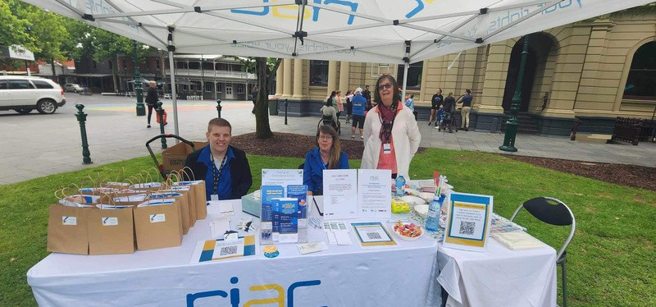

Feonyx, Carolyn & Sherrie representing RIAC at International Day of People with Disability event in Bendigo.

## CASE STUDY

**ADVOCACY FOR FRED (DE-IDENTIFIED)**

Fred, a man with a traumatic brain injury, was subjected to financial abuse and over-medication by his wife. She gambled his money away at the pokies, administered extra medications, and convinced others that Fred was dying.

Due to the urgency and lack of local advocacy capacity, remote advocacy was initiated to ensure Fred’s voice was heard and to support him in making informed decisions.

Our efforts to resolve this included coordinating with the support workers to ensure they were available to assist Fred. We also worked with Fred to understand his wishes and to provide him with options.

We encouraged Fred to report his wife to the police and assisted him to obtain an intervention order and arranged for a support worker to help him to set up a new bank account to prevent his wife from accessing his money. We also contacted Centrelink with Fred’s consent to stop his wife from accessing his account. This support enabled Fred to regain control of his life and make his own decisions.

Through 15.5 hours of dedicated advocacy, Fred took significant steps towards reclaiming his autonomy and financial security. The advocacy efforts prioritized Fred’s needs and wishes, providing him with the tools and support necessary to rebuild his life.

This case highlights the critical role of advocacy in protecting vulnerable individuals from abuse and ensuring their voices are heard. By providing tailored support and empowering Fred, the advocacy team made a profound impact on his life.

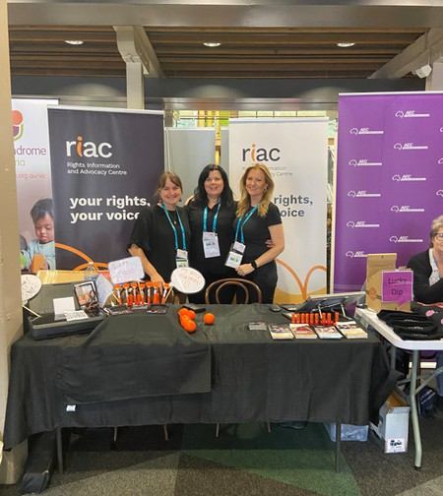

Susie, Jackie and Anna at the 2024 VALiD Having A Say Conference in Geelong.

## SYSTEMIC ADVOCACY

We were involved in a number of systemic advocacy initiatives in the 2023/24 financial year. These included:

Child Protection – Community of Practice

RIAC has been a core organisation in developing and maintaining a community of practice between organisations supporting people with disabilities navigating Child Protection processes and involvement.

The network meets to share experiences, reflect on case studies and discuss best practice approaches. It also aims to identify systemic issues and bring these to the attention of Child Protection.

 Victorian Disability Advocacy Network (VicDAN)

RIAC co-chairs the monthly VicDAN meetings alongside Victoria Legal Aid (VLA).

As well as addressing NDIS Appeals issues within the network, guest speakers from all areas of the NDIA attend.

The NDIA’s community engagement officers also attend to identify any systemic issues they can support to elevate.

 Victorian Regional Advocacy Network (VicRAN)

RIAC is a member of VicRAN which has an element of systemic advocacy. RIAC collaborates with the network to bring a voice to issues specific to regional and rural advocacy organisations throughout Victoria.

RIAC also contributed to a VicRAN project to make a submission to the NDIS Joint Standing Committee on the NDIS participant experience in rural, regional and remote Australia.

 Disability Advocacy Resource Unit (DARU)

RIAC regularly engages with DARU to provide feedback and recommendations regarding webinars and resources to support the Victorian disability advocacy sector.

## SYSTEMIC ADVOCACY

Disability Advocacy Victoria (DAV)

RIAC is a member of Disability Advocacy Victoria (DAV) which provides a systemic voice for disability advocacy organisations within Victoria. RIAC has contributed to several submissions, including a submission to the Disability Royal Commission. RIAC’s CEO Dr Sandy Ross is also on the DAV Committee of Management.

RIAC is also involved in the Family Violence Disability Practice Lead Steering Committee which is hosted by the Centre for Non-Violence. This is a relatively new group that is looking at the systemic issues around awareness of the intersectionality between Family Violence and Disability. Other members include VALiD, Women with Disabilities Victoria, Victorian Department of Families, Fairness and Housing.

NDIA National Call Centre bimonthly meetings to discuss issues around the need to escalate some issues on behalf of clients.

 Disability Advocacy Network Australia (DANA)

RIAC is a member of DANA which is the peak body for advocacy organisations in Australia. We regularly contribute to their systemic advocacy work. RIAC’s Director of Advocacy, David Petherick is the Deputy Chairperson of DANA.



## ACCESS & SUPPORT

###### RIAC offers crucial support to people over 65 (over 50 for First Nations people), focusing on empowering them to live independently and safely in their homes and communities through its Access and Support Program.

We provide free, confidential, and independent assistance to help you connect with services. Whether it’s understanding the My Aged Care process, applying for Home Care Packages, or assistance with everyday needs and paperwork, our team is here for you. From navigating the registration process to liaising with service providers, our Access and Support team is dedicated to meeting your needs and enhancing your independence.

Our Access and Support Program is available across the Local Government Areas of Greater Bendigo, Loddon, Gannawarra, Swan Hill, Mildura, Central Goldfields, Campaspe, Mount Alexander and Macedon Ranges.

## ACCESS & SUPPORT

###### RIAC’s Access and Support Program is dedicated to helping people under 65, promoting independence and safety in their homes and communities.



Our free service supports diverse groups, including those financially or socially disadvantaged, with dementia or cognitive impairments, living in rural areas, or from diverse cultural backgrounds.

We assist with navigating services, information about the NDIS process, referrals, home help, gathering evidence for NDIS and Centrelink, completing paperwork, and attending appointments.

The program is available across the Local Government Areas of Greater Bendigo, Swan Hill, and Mildura.

## ACCESS & SUPPORT

#### HACC CASE STUDY

Gary P. (64) lives with Parkinson’s Disease and had previously applied twice for NDIS supports, for which he was rejected both times. A friend had provided Gary with RIAC’s Intake phone number, so Gary decided to make the call for assistance. Gary’s matter was allocated to an Access and Support Officer (Vereena) within a week, and Gary was happy with the speed of our attendance. At that time, Gary felt that he “didn’t meet the criteria, so I took it on the chin, but never gave up!”

When reviewing Gary’s previous applications, it was determined that there could be improvements made to the quality of his application, including the use of more appropriate terminology and descriptions of his condition as well as more in-depth information as supporting evidence. Gary knew the process but was not fully aware of the criteria.

Gary was promptly referred for an Occupational Therapist Full Capacity Assessment at Bendigo Health by RIAC, and Home and Community Care Program for Younger People (HACC PYP) services. Gary then had domestic assistance in his home, funded by HACC, while he was gathering evidence for NDIS. During this time, Gary changed doctors and now feels supported by his GP. Once a new application was completed with another Access and Support Officer’s (Cristie) assistance, it was reviewed and signed by his new GP and submitted to NDIS.

“Good afternoon Vereena/Cristie, Just got a phone call from NDIS and I have been accepted, so I would like to thank you both for your assistance in getting this application through.” – Gary P.

Due to Gary’s issue with communication (slowed speech), Cristie accompanied him by phone to his first Planning Meeting with Intereach to ensure that Gary was given the time and space for his voice to be heard. Gary P. – “Cristie is a gun!”



Gary has since received an NDIS Plan and has been provided with funds to assist him to receive the supports that he needs to continue living in his home with an improved quality of life. At last report, Gary’s home is set to undergo modifications which will be funded by NDIS. Gary was involved with RIAC for 12 months in total and was able to achieve what he could not before RIAC’s involvement.

“Cristie and Vereena were very helpful in explaining the process and what was needing to be done to make my application more viable. They both have great empathy and patience which is needed in their roles. I would like to personally thank them both for their persistence and help in my application for NDIS.”

-Gary P.

## ACCESS & SUPPORT

#### CHSP CASE STUDY

**Steve – Rural and Remote with escalating support needs, ineligible for Carefinder**

Steve is a 74-year-old who lives alone in rural Victoria following the loss of his wife 12 months ago. Steve has help from his daughter who recently had to leave work to care for her father. Steve’s daughter, who lives 40 mins away, wanted to get services in place so Steve can live at home independently but had no idea how to navigate the Aged Care System.

RIAC’s Access and Support Team received a request for help for Steve from his daughter and began the process of assisting Steve’s daughter to get services in place. At the initial meeting it was determined that Steve required a lot of help to remain living at home with in-home services and an Occupational Therapist assessment for Rails and Ramps around the home.

RIAC completed referrals for an ACAS assessment and Occupational Therapist assessment but advised Steve’s daughter that the process might take some time due to wait times. Steve then suffered a stroke and ended up living with his daughter meaning it became more urgent that assessments were completed as soon as possible.

RIAC made contact with ACAS and had to advocate for Steve as they initially weren’t going to do the assessment but eventually convinced ACAS to do an assessment for Steve and it was determined that he required a Level 4 Home Care package with a high priority for allocation of a package.

Steve’s carer stated she was thankful that RIAC was involved as she would have had no idea how to start this process. RIAC continues to follow up with Steve and his daughter.

*“I don’t know where I would be without RIAC. I was in no state of mind to do anything and was concerned I would lose my home. I’m in a place of peace now.” - CHSP client*

## VOLUNTEER PROGRAM



Volunteering at RIAC is a rewarding opportunity to make a meaningful difference while developing your skills and knowledge.

Why volunteer?

Community contribution

Your efforts directly support individuals with disabilities. Skill development

Gain practical experience and develop new skills in a supportive environment. Networking

Connect with professionals in the advocacy and non-profit sector.

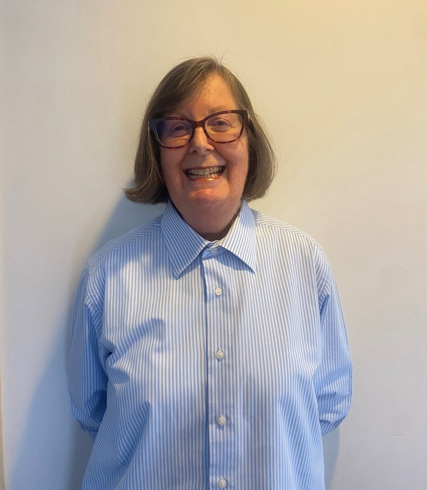Picture: Sherrie Gumley, Volunteer at RIAC Bendigo.

## INFORM HUB

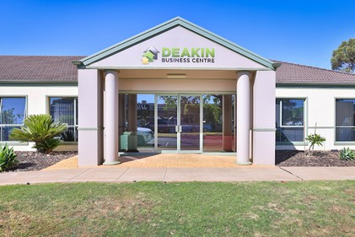Every Tuesday, we open our Mildura and Bendigo offices for members of the community to walk in and get on-the-spot assistance. From assisting them to fill out a form, or navigating technology, we are there to help.

## STRENGTHENING PARENTS SUPPORT PROGRAM

Our SPSP program continues to provide parents and carers of children living with disability ongoing support and access to social connection and peer support.

In addition to our regular groups in Castlemaine and Bendigo, we now offer carer support groups in Echuca, and for those experiencing difficulties getting out and about, we have an online carer support group.

Our self-care model approach has been very well received by carers and parents. Those attending our self-care hubs have the opportunity to engage in a variety of activities that promote relaxation and stress reduction. In addition, feedback from carers indicates they especially enjoy the periodic visits from massage and art therapists.

We are also continuing our focus on supporting parents and carers to ensure their children have positive educational experiences and a smooth transition into post-school options. Group attendees are regularly updated on upcoming webinars and presentations that focus on education and post-school options. In addition, in January and February of this year, we presented a 2-part series on negotiating the education system with guest speaker Kim Alexander. Parents and carers who attended greatly appreciated the information and strategies presented.

“There is a lot of mental stress off me and reduced burn-out. It helps knowing that there are people out there that will help advocate for people with disabilities.” - SPSP client



**INTAKE**

Jackie and Shelbey

##### RIAC has experienced a consistent increase in intake enquiries, reflecting a growing demand for service. This upward trend has been observed month-on-month, indicating a continuous interest from individuals seeking assistance.

In the financial year ending 2024, RIAC received 2,172 enquiries, up from 1,936 enquiries the previous year, marking a 12.2% increase. Additionally, over the past three months, RIAC has been averaging 200 enquiries per month, which suggests the potential for an even higher percentage increase for the year ending 2025. As a result, the waitlist for those needing support has also seen a significant rise. This surge in enquiries can be attributed to several factors, the increasing awareness of RIAC’s services, successful networking/outreach initiatives, and an overall increase in community needs.

Intake has been working diligently to manage this influx, ensuring that each enquiry is addressed promptly and efficiently. However, the growing waitlist highlights the need for additional resources and support to meet the rising demand. RIAC remains committed to providing high-quality assistance to all individuals and is exploring various strategies to expand its capacity and reduce wait times, ensuring that everyone receives the help they need in a timely manner.

**INTAKE DATA**

**5 9 5**

**V I A E M A I L**

**5 2 1**

**V I A O U R W E B S I T E**

**1 0 5 6**

**V I A P H O N E**

**E N Q U I R I E S**

**A L L P R O G R A M S**

**2172**

**T H E N U M B E R O F E N Q U I R I E S E A C H M O N T H F O R T H E 2 0 2 3 - 2 0 2 4 F I N A N C I A L Y E A R**

250

200

150

100

50

0



This report was designed by Lauren Burchell, Executive Assistant at RIAC.

[www.riac.org.au](http://www.riac.org.au/)

[referrals@riac.org.au](mailto:referrals@riac.org.au)

**CONTACT**

Intake Team 03 5222 5499

## ACKNOWLEDGEMENTS

**W E W O U L D L I K E T O A C K N O W L E D G E O U R F U N D I N G B O D I E S .**

**R I A C T H A N K S I T S V O L U N T E E R S , S U P P O R T E R S A N D O T H E R S T A K E H O L D E R S F O R T H E I R C O N T I N U E D**

**S U P P O R T O F O U R A D V O C A C Y A N D A C C E S S & S U P P O R T S E R V I C E S .**



**2023-2024**

**FINANCIAL STATEMENTS**

**Rights Information and Advocacy Centre Inc.**

ABN 42 401 261 070

**Financial Statements - 30 June 2024**

Committees' report 2

Auditor's Independence Declaration 4

Statement of profit or loss and other comprehensive income 5

Statement of financial position 6

Statement of changes in equity 7

Statement of cash flows 8

Notes to the financial statements 9

Committees' declaration 24

Independent auditor's report to the members of Rights Information and Advocacy Centre Inc. 25

Your committee members submit the financial report of the Rights Information and Advocacy Centre Inc. for the financial year ended 30 June 2024.

Committee members

The following persons were committee members of the association during the whole of the financial year and up to the date of this report, unless otherwise stated:

Carli Leishman (Chairperson) Shannon Burdeau (Vice Chairperson) Kathryn Londrigan (Secretary)

Beau Mittner (Treasurer) Bich Jennings

Louise Halliwell Mark Poswiat

Ainslee Hooper (appointed 20 May 2024)

Dianne Thomson (appointed 20 May 2024)

Michael Curtis (resigned 31 August 2023)

Principal activities

The principal activity of the association during the financial year was to deliver programs which help to build capacity and wellbeing of individuals, families, carers and communities through advocacy and support services.

|  |  |  |
| --- | --- | --- |
| **Operating result**  The surplus/(deficit) of the association was: |  | |
|  | **2024**  **$** | **2023**  **$** |
|  | 321,386 | (686,697) |

Included in the results for the year ended 30 June 2024 is the following item:

Merger

On 20 May 2024, Rights Information and Advocacy Centre Inc. (RIAC) merged with Barwon Disability Resource Council Incorporated (BDRC). As part of the merger, RIAC acquired BDRC's assets and assumed its liabilities, which were transferred to RIAC at their carrying amount for nil consideration. This gave rise to a significant gain on bargain purchase of

$884,027 which is recognised in the surplus. The merger was also attributable to material increases in the associations revenue, expenditure, assets and liabilities.

Included in the results for the year ended 30 June 2023 are the following items: Provision for staff backpays

Following the commencement of the new CEO in May 2023 and the emergence of some risk indications, including some staff concerns, RIAC established a classification review process. This identified instances where employees had not been correctly classified based on the core responsibilities of their roles. A number of then current employees had subsequently been reclassified and their rate of pay corrected. For these employees, and a number of then former employees also impacted by the errors, backpay calculations were been performed.

The total impact of this equated to $284,436, this was recognised as a liability at 30 June 2023 and paid during the current financial year.

Disability Royal Commission funding refund obligation

The Disability Royal Commission (DRC) program ceased under the terms of legislation on 30 June 2023, with a requirement that all unspent funds be repaid to the Department of Social Services. RIAC initially assessed an approximate underspend of $160,000 in this program for which repayment would be required. In calculating the aforementioned backpay liabilities, RIAC allocated liabilities against the relevant programs, which amounted to an adjustment in salary costs for each program. Through this process, RIAC assessed that the underspend amount for the DRC should be adjusted down to offset approximately $7,000 in backpay liabilities, with the remainder of $153,000 to be returned to the Department.

Therefore the impact of the DRC refund obligation equated to $153,000, this remained unpaid at 30 June 2024 and was paid during August 2024.

Significant changes

On 20 May 2024, RIAC merged with BDRC. Under the merger agreement, all operating assets and liabilities of BDRC transferred to RIAC effective 20 May 2024.

The impact of this merger is explained within the financial statements.

No further significant changes in the association's state of affairs occurred during the financial year.

Events subsequent to the end of the reporting period

There are no matters or circumstances that have arisen since the end of the financial year that have significantly affected or may significantly affect the operations of the association, the results of those operations or the state of affairs of the association, in future years.

Signed in accordance with a resolution of the members of the committee:



Carli Leischman Shannon Burdeau

Chairperson Vice Chairperson

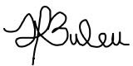

19 September 2024

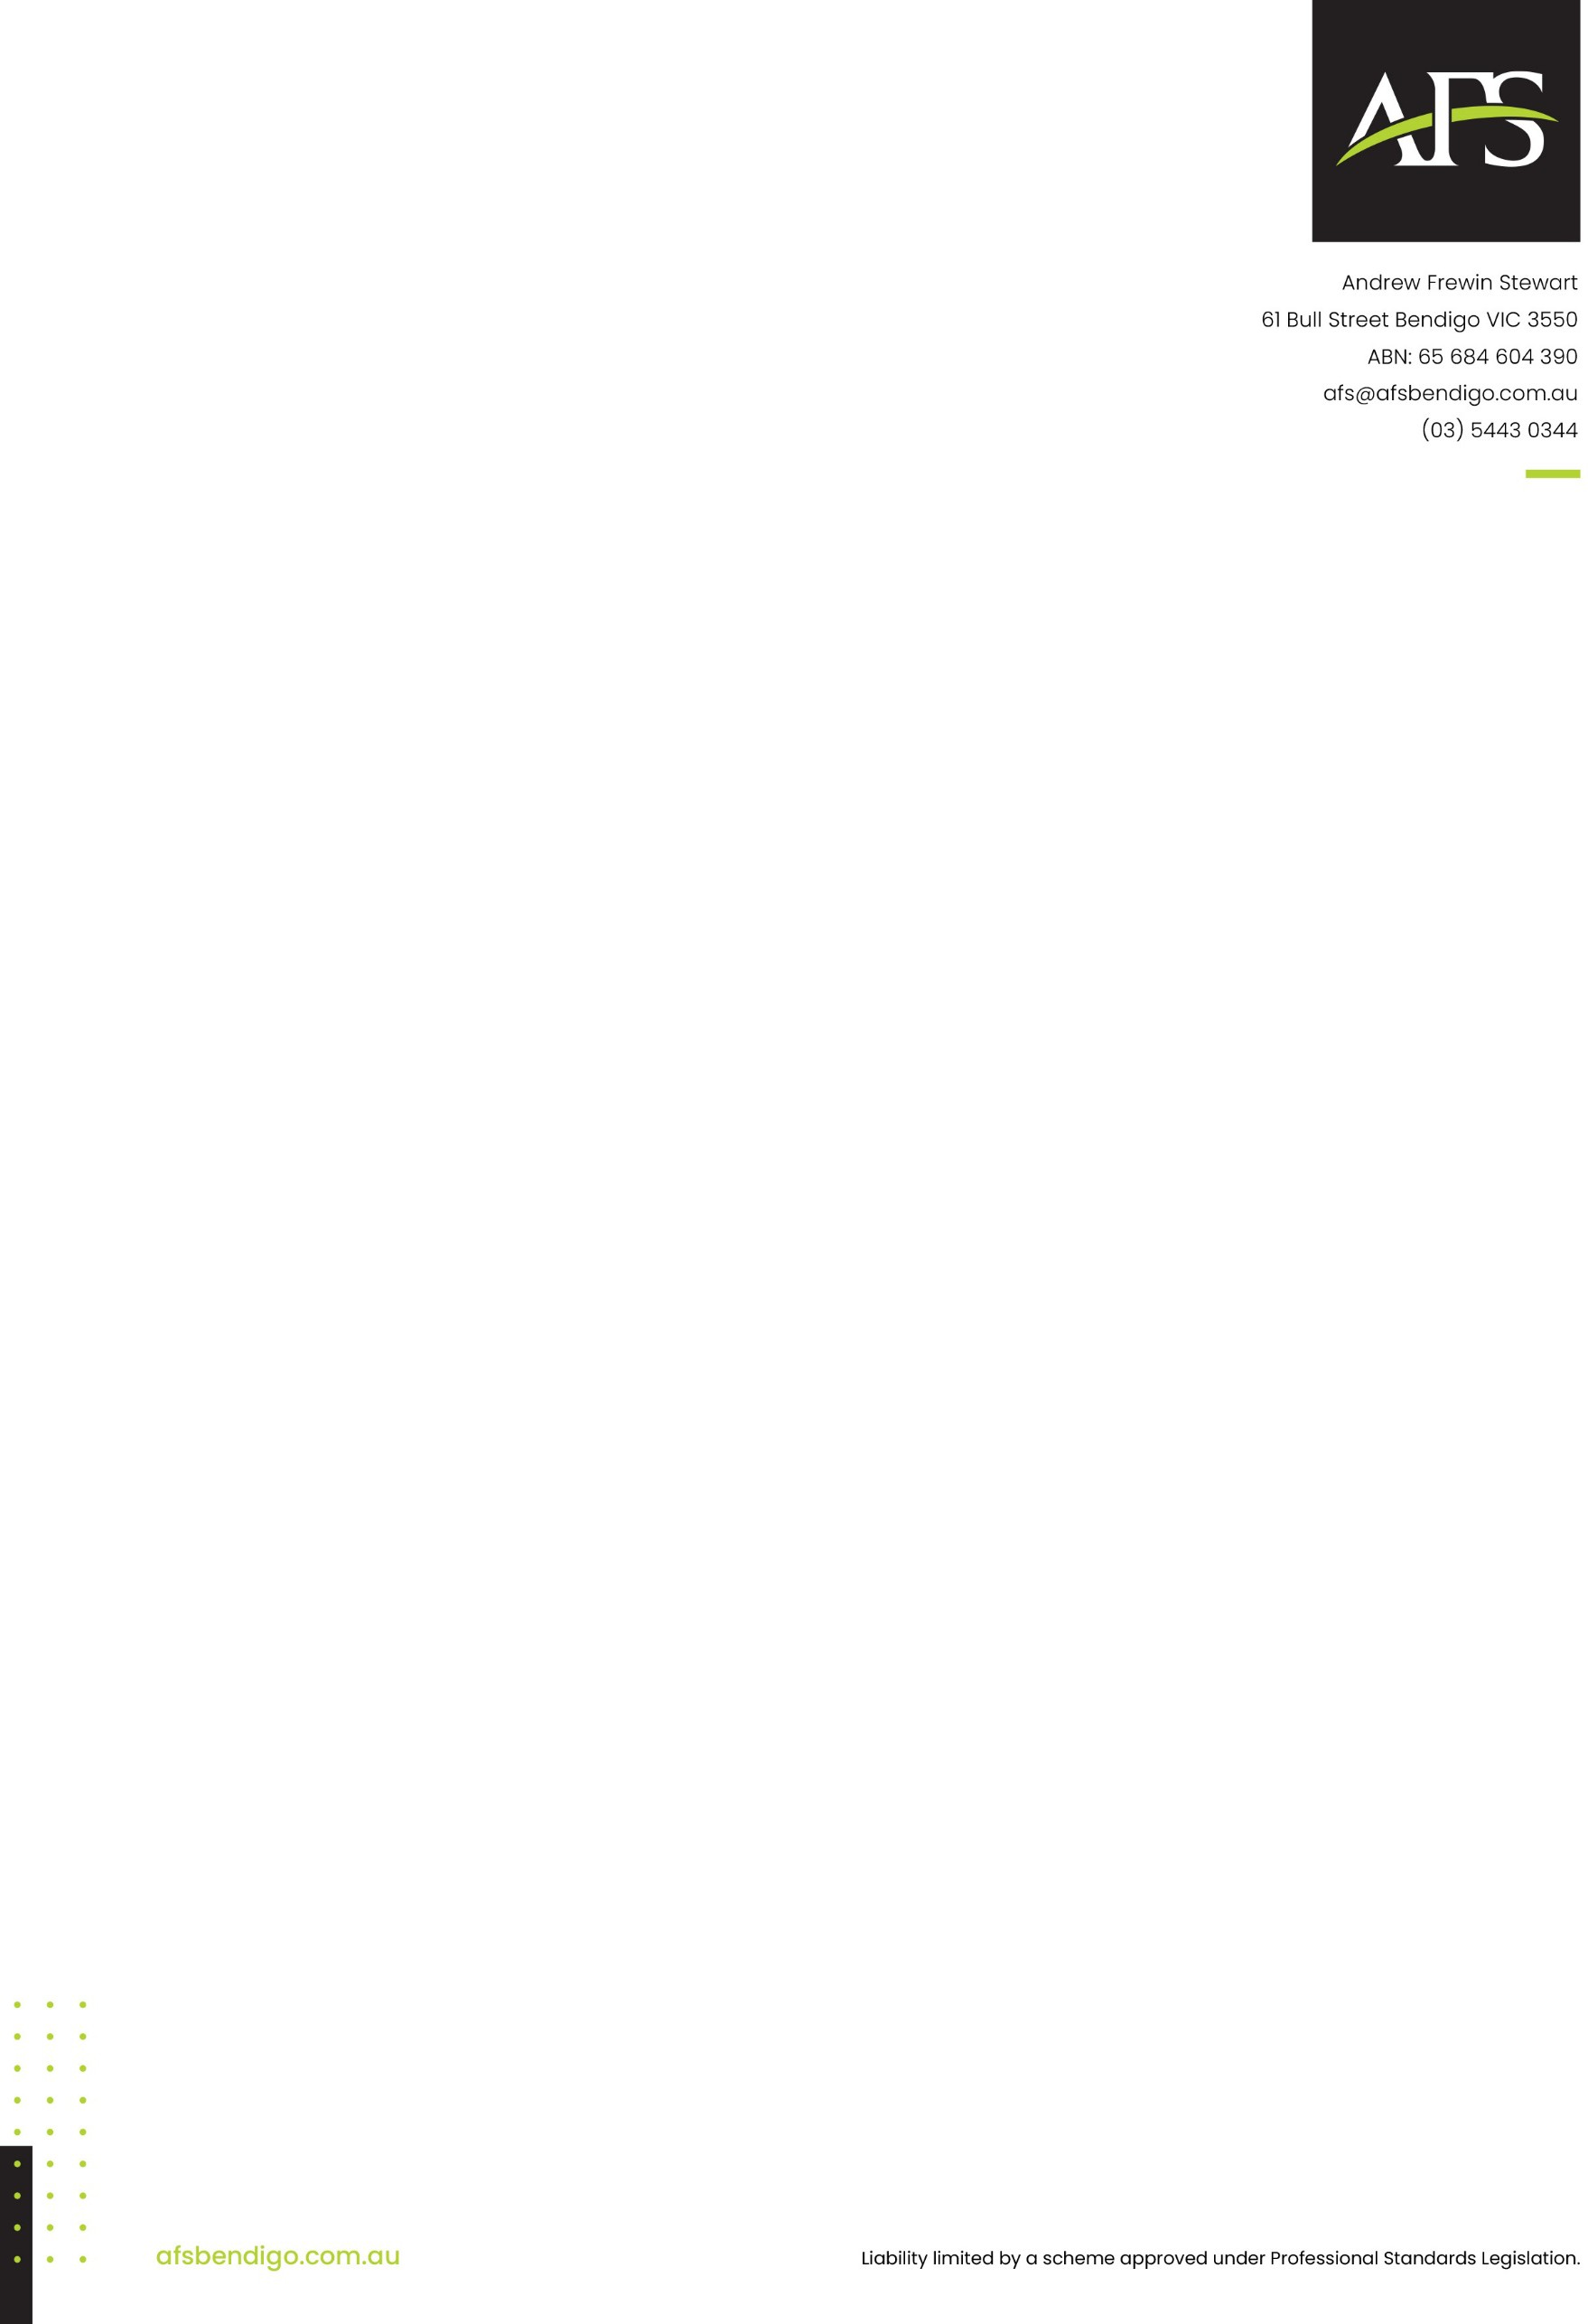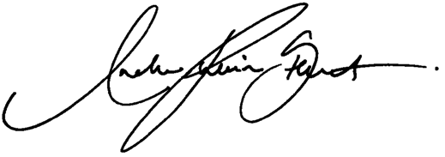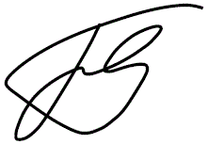

Lead auditor’s independence declaration under section 60-40 of the *Australian Charities and Not-for-profits Commission Act 2012* to the Directors of Rights Information and Advocacy Centre Inc

As lead auditor for the audit of Rights Information and Advocacy Centre Inc for the year ended 30 June 2024, I declare that, to the best of my knowledge and belief, there have been:

1. no contraventions of the auditor independence requirements of the *Australian Charities and Not-for- profits Commission Act 2012* in relation to the audit, and
2. no contraventions of any applicable code of professional conduct in relation to the audit.

**Andrew Frewin Stewart Joshua Griffin**

61 Bull Street, Bendigo Vic 3550 **Lead Auditor**

Dated 19th September 2024

|  |  |  |  |
| --- | --- | --- | --- |
| **Statement Of Profit Or Loss And Other Comprehensive Income For the year ended 30 June 2024** |  | | |
|  | **Note** | **2024**  **$** | **2023**  **$** |
| **Revenue and other income** | 3 | 2,042,384 | 2,208,914 |
| Gain from bargain purchase from merger | 4 | 884,027 | - |
| **Expenses**  Employee benefits expense |  | (2,002,371) | (2,272,310) |
| Administration and other associated costs |  | (330,957) | (363,143) |
| Depreciation expense | 5 | (102,410) | (105,799) |
| Information technology costs |  | (77,922) | (78,619) |
| Motor vehicle expenses |  | (50,817) | (29,082) |
| Occupancy and associated costs |  | (18,798) | (10,842) |
| Other expenses | 5 | (15,673) | (29,378) |
| Finance costs | 5 | (6,077) | (6,438) |
| **Surplus/(deficit) for the year attributable to the members of Rights Information and Advocacy Centre Inc.** |  | 321,386 | (686,697) |

Other comprehensive income for the year - -

Total comprehensive income for the year attributable to the members of Rights

**Information and Advocacy Centre Inc.**  321,386 (686,697)

*The above Statement of profit or loss and other comprehensive income should be read in conjunction with the accompanying notes*

|  |  |  |  |
| --- | --- | --- | --- |
| **Statement Of Financial Position As at 30 June 2024** |  | | |
|  | **Note** | **2024**  **$** | **2023**  **$** |
| **Assets** |  |  |  |
| **Current assets**  Cash and cash equivalents | 6 | 941,441 | 1,538,587 |
| Trade and other receivables | 7 | 329,088 | 17,469 |
| Other assets |  | 6,197 | 6,591 |
| Total current assets |  | 1,276,726 | 1,562,647 |
| **Non-current assets**  Property, plant and equipment | 8 | 791,871 | 88,417 |
| Right-of-use assets | 9 | 108,120 | 58,026 |
| Total non-current assets |  | 899,991 | 146,443 |
| **Total assets** |  | 2,176,717 | 1,709,090 |
| **Liabilities** |  |  |  |
| **Current liabilities**  Trade and other payables | 10 | 63,886 | 428,908 |
| Other liabilities | 11 | 821,296 | 388,425 |
| Lease liabilities | 12 | 67,731 | 39,912 |
| Employee benefits | 13 | 112,160 | 93,208 |
| Total current liabilities |  | 1,065,073 | 950,453 |
| **Non-current liabilities**  Lease liabilities | 12 | 52,380 | 26,345 |
| Employee benefits | 13 | 11,047 | 5,461 |
| Total non-current liabilities |  | 63,427 | 31,806 |
| **Total liabilities** |  | 1,128,500 | 982,259 |
| **Net assets** |  | 1,048,217 | 726,831 |
| **Equity**  Unspent grants reserve |  | - | 547,671 |
| Retained surplus |  | 1,048,217 | 179,160 |
| **Total equity** |  | 1,048,217 | 726,831 |

*The above Statement of financial position should be read in conjunction with the accompanying notes*

|  |  |  |  |
| --- | --- | --- | --- |
| **Statement Of Changes In Equity For the year ended 30 June 2024** |  |  |  |
|  | **Unspent grants** | **Retained** |  |
|  | **reserve**  **$** | **surplus**  **$** | **Total equity**  **$** |
| Balance at 1 July 2022 | 713,780 | 699,748 | 1,413,528 |
| Deficit for the year | - | (686,697) | (686,697) |

Other comprehensive income for the year - - -

Total comprehensive income for the year - (686,697) (686,697)

Transfer (from)/to unspent grants reserve (166,109) 166,109 - Balance at 30 June 2023 547,671 179,160 726,831

|  |  |  |  |
| --- | --- | --- | --- |
|  | **Unspent**  **grants** | **Retained** |  |
| **reserve**  **$** | **surplus**  **$** | **Total equity**  **$** |
| Balance at 1 July 2023 | 547,671 | 179,160 | 726,831 |
| Surplus for the year | - | 321,386 | 321,386 |

Other comprehensive income for the year - - -

Total comprehensive income for the year - 321,386 321,386

Transfer (from)/to unspent grants reserve (547,671) 547,671 - Balance at 30 June 2024 - 1,048,217 1,048,217

*The above Statement of changes in equity should be read in conjunction with the accompanying notes*

|  |  |  |  |
| --- | --- | --- | --- |
|  | **Note** | **2024**  **$** | **2023**  **$** |
| **Cash flows from operating activities**  Receipts from customers and government grants |  | 2,366,213 | 2,804,465 |
| Payments to suppliers and employees |  | (3,044,015) | (2,732,411) |
| Interest received |  | 10,736 | 13,752 |
| Finance costs |  | (6,077) | (6,438) |
| Net cash from/(used in) operating activities | 14 | (673,143) | 79,368 |
| **Cash flows from investing activities**  Cash and cash equivalents acquired from merger | 4 | 146,988 | - |
| Payments for property, plant and equipment | 8 | (8,227) | (48,944) |
| Proceeds from disposal of property, plant and equipment |  | 3,504 | - |
| Net cash from/(used in) investing activities |  | 142,265 | (48,944) |
| **Cash flows from financing activities**  Repayment of lease liabilities |  | (66,268) | (80,484) |
| Net cash used in financing activities |  | (66,268) | (80,484) |
| Net decrease in cash and cash equivalents |  | (597,146) | (50,060) |
| Cash and cash equivalents at the beginning of the financial year |  | 1,538,587 1,588,647 | |
| Cash and cash equivalents at the end of the financial year | 6 | 941,441 1,538,587 | |

*The above Statement of cash flows should be read in conjunction with the accompanying notes*

The financial statements cover Rights Information and Advocacy Centre Inc. as an individual entity, incorporated and domiciled in Australia.

Basis of preparation

These general purpose financial statements have been prepared in accordance with the Australian Accounting Standards - Simplified Disclosures issued by the Australian Accounting Standards Board ('AASB'), the *Australian Charities and Not-for- profits Commission Act 2012* and the *Associations Incorporation Reform Act 2012.*

Statement of compliance

These general purpose financial statements have been prepared in accordance with the Australian Accounting Standards - Simplified Disclosures issued by the Australian Accounting Standards Board ('AASB'), the *Australian Charities and Not-for- profits Commission Act 2012* and the *Associations Incorporation Reform Act 2012.*

The association does not have ‘public accountability’ as defined in AASB 1053 *Application of Tiers of Australian Accounting Standards* and is therefore eligible to apply the ‘Tier 2’ reporting framework under Australian Accounting Standards.

The financial statements comply with the recognition and measurement requirements of Australian Accounting Standards, the presentation requirements in those Standards as modified by AASB 1060 *General Purpose Financial Statements* ‐ *Simplified Disclosures for For‐Profit and Not‐for‐Profit Tier 2 Entities* (AASB 1060) and the disclosure requirements in AASB 1060.

Going concern

The financial report has been prepared on a going concern basis, which contemplates continuity of normal business activities and the realisation of assets and the settlement of liabilities in the ordinary course of business.

Functional and presentation currency and rounding

These financial statements are presented in Australian dollars, which is the association’s functional currency. The amounts have been rounded to the nearest dollar.

Historical cost convention

The financial statements have been prepared under the historical cost convention.

Adoption of new and revised accounting standards

The association has adopted all of the new or amended Accounting Standards and Interpretations issued by the AASB that are mandatory for the current financial year. A description of the impact of new or amended Accounting Standards and Interpretations that have had a material impact on the association during the current financial year is outlined below:

AASB 2021-2 *Amendments to Australian Accounting Standards – Disclosure of Accounting Policies and Definition of Accounting Estimates* is mandatory for annual reporting periods beginning on or after 1 January 2023 and was adopted by the association in the preparation of the 30 June 2024 financial statements.

AASB 2021-2 includes amendments to AASB 101 *Presentation of Financial Statements*, requiring the association to disclose material accounting policy information in its financial statements rather than significant accounting policies which was required in previous financial years. Accounting policy information is material if it, when considered with other information, could reasonably be expected to influence decisions of primary users based on the financial statements.

Adoption of AASB 2021-2 has had no impact on the numerical information disclosed in the association’s financial statements. Rather, adoption has required the association to remove significant accounting policy information from the notes to the financial statements that is not considered material.

The accounting policies that are material to the incorporated association are set out either in the respective notes or below. The accounting policies adopted are consistent with those of the previous financial year, unless otherwise stated.

Current and non-current classification

Assets and liabilities are presented in the statement of financial position based on current and non-current classification.

Critical accounting estimates

The preparation of the financial statements requires the use of certain critical accounting estimates. It also requires management to exercise its judgement in the process of applying the association's accounting policies. The areas involving a higher degree of judgement or complexity, or areas where assumptions and estimates are significant to the financial statements, are disclosed in Note 2.

Foreign currency translation

The financial statements are presented in Australian dollars, which is Rights Information and Advocacy Centre Inc.'s functional and presentation currency.

*Foreign currency transactions*

Foreign currency transactions are translated into Australian dollars using the exchange rates prevailing at the dates of the transactions. Foreign exchange gains and losses resulting from the settlement of such transactions and from the translation at financial year-end exchange rates of monetary assets and liabilities denominated in foreign currencies are recognised in profit or loss.

Unspent grants reserve

The unspent grants reserve represents funds that have been received and not yet spent in the manner, intention or purpose as defined within the applicable funding agreement. Whilst the association may have satisfied the performance obligations under the funding agreement and is required to recognise income under AASB 15: *Revenue from Contracts with Customers*, or is required to recognise income under AASB 1058: *Income of Not-for-Profit Entities* due to the funding agreement not containing sufficiently specific or enforceable performance obligations, the association is still obligated to spend the remaining funds in accordance with the funding agreement. Once the funds have been expended in accordance with the funding agreement, the amounts recorded in the reserve will be transferred to accumulated surplus.

Economic dependence

The association is dependent on the Commonwealth and State Government for the majority of its revenue used to fund the operations of the organisation. At the date of this report, the committee members believe the Government will continue to support the association and its operations.

Note 2. Critical accounting judgements, estimates and assumptions

The committee members evaluate estimates and judgements incorporated into the financial statements based on historical knowledge and best available current information. Estimates assume a reasonable expectation of future events and are based on current trends and economic data, obtained both externally and within the association.

Key estimates

*Impairment*

The association assesses impairment at the end of each reporting period by evaluation of conditions and events specific to the association that may be indicative of impairment triggers. Recoverable amounts of relevant assets are reassessed using value-in-use calculations which incorporate various key assumptions.

*Useful life of plant and equipment*

The association reviews the estimated useful lives of plant and equipment at the end of each annual reporting period.

Key judgements

*Identifying performance obligations under AASB 15*

To identify a performance obligation under AASB 15, the promise must be sufficiently specific to be able to determine when the obligation is satisfied. Management exercises judgement to determine whether the promise is sufficiently specific by taking into account any conditions specified in the arrangement, explicit or implicit, regarding the promised goods or services. In making this assessment, management includes the nature/-type, cost/-value, quantity and the period of transfer related to the goods or services promised.

*Determination and timing of revenue recognition under AASB 15*

For each revenue stream, the association applies significant judgement to determine when a performance obligation has been satisfied and the transaction price that is to be allocated to each performance obligation.

Government grants:

The association has a range of funding agreements with the Commonwealth and State Government which require the association to deliver services to members of the community. Revenue from government grants is recognised over time as outputs/targets are satisfied, being the time of which promised goods and services are transferred to customers.

Where the association has not fulfilled a sufficiently specific output/target under a contract with a customer, the association recognises a liability in the Statement of Financial Position to reflect it's obligation to transfer promised goods and services at balance date. The obligation is recognised as revenue as and when promised goods and services are transferred, or on the date a contract modification is entered into with the funding body, waiving the association's obligation to transfer promised goods and services to customers. Where the parties to a contract have not approved a contract modification at balance date, the association continues to apply AASB 15 to the existing contract until the contract modification is approved.

*Lease term and option to extend under AASB 16*

The lease term is defined as the non-cancellable period of a lease together with both periods covered by an option to extend the lease if the lessee is reasonably certain to exercise that option; and also periods covered by an option to terminate the lease if the lessee is reasonably certain not to exercise that option. The options that are reasonably going to be exercised is a key management judgement that the association will make.

The association determines the likelihood to exercise the options on a lease-by-lease basis, looking at various factors such as which assets are strategic and which are key to future strategy of the association, in addition to the following:

* If there are significant penalties to terminate (or not to extend), the association is typically reasonably certain to extend (or not terminate).
* If any leasehold improvements are expected to have a significant remaining value, the association is typically reasonably certain to extend (or not terminate).
* Otherwise, the association considers other factors including historical lease durations and the costs and business disruption required to replace the leased asset.

Where the association's lease arrangements include a market review, this is treated as a variable lease payment included in the measurement of the lease liability, resulting in the market review being included in the measurement of the lease liability and right-of-use asset once it becomes effective.

*Borrowing rate under AASB 16*

The lease payments are discounted using the interest rate implicit in the lease. If that rate cannot be readily determined, which is generally the case for the association's leases, the association's incremental borrowing rate is used, being the rate that the association would have to pay to borrow the funds necessary to obtain an asset of similar value to the right-of-use asset in a similar economic environment with similar terms, security and conditions.

To determine the incremental borrowing rate, the association:

* where possible, uses recent third-party financing received by the individual lessee as a starting point, adjusted to reflect changes in financing conditions since third party financing was received
* makes adjustments specific to the lease, eg term, country, currency and security.

*Employee benefits*

For the purpose of measurement, AASB 119: *Employee Benefits* defines obligations for short-term employee benefits as obligations expected to be settled wholly before 12 months after the end of the annual reporting period in which the employees render the related service.

As the association expects that all of its employees would use all of their annual leave entitlements earned during a reporting period before 12 months after the end of the reporting period, the association believes that obligations for annual leave entitlements satisfy the definition of short-term employee benefits and, therefore, can be measured at the (undiscounted) amounts expected to be paid to employees when the obligations are settled.

|  |  |  |
| --- | --- | --- |
| **Note 3. Revenue and other income** |  | |
|  | **2024**  **$** | **2023**  **$** |
| *Revenue*  Revenue from contracts with customers | 2,031,284 | 2,193,593 |
| *Other income*  Other sources of income | 11,100 | 15,321 |
| Revenue and other income | 2,042,384 | 2,208,914 |
| **Revenue from contracts with customers** |  |  |

The association has disaggregated revenue from contracts with customers by the nature of revenue and timing of revenue recognition.

|  |  |  |
| --- | --- | --- |
| The disaggregation of revenue from contracts with customers is as follows: |  | |
|  | **2024**  **$** | **2023**  **$** |
| Department of Health (State) | 323,907 | 299,710 |
| Department of Families, Fairness and Housing (State) | 339,899 | 143,733 |
| Department of Health (Commonwealth) | 160,450 | 142,257 |
| Department of Social Services (Commonwealth) | 1,203,992 | 1,601,910 |
| Other grants 3,036 5,983 | | |
| Total revenue from contracts with customers | 2,031,284 | 2,193,593 |
| *Timing of revenue recognition*  Services transferred over time | 2,031,284 | 2,193,593 |

*Restatement of comparatives*

In the current year it was identified that the comparative values for 2023 disaggregation of revenue were materially incorrect. Comparative figures have been restated in this report. This restatement was a reclassification only and had no impact on total revenue.

|  |  |  |  |
| --- | --- | --- | --- |
| **Other sources of income** |  | | |
|  | **2024**  **$** |  | **2023**  **$** |
| Donations |  | 91 | 1,114 |
| Membership fees |  | 273 | 455 |
| Interest received | 10,736 13,752 | | |
| Total other income | 11,100 15,321 | | |
| **Accounting policy for revenue and other income** |  | | |

*Government grants*

When the association receives grant revenue, it assesses whether the contract is enforceable and has sufficiently specific performance obligations in accordance to AASB 15.

When both these conditions are satisfied, the association:

* identifies each performance obligation relating to the grant
* recognises a contract liability for its obligations under the agreement
* recognises revenue as it satisfies its performance obligations, at the time of which services are rendered.

Where the contract is not enforceable or does not have sufficiently specific performance obligations, the association:

* recognises the asset received in accordance with the recognition requirements of other applicable Accounting Standards (for example AASB 9: *Financial Instruments*, AASB 16: *Leases*, AASB 116: *Property, Plant and Equipment* and AASB 138: *Intangible Assets*)
* recognises related amounts (being contributions by owners, lease liability, financial instruments, provisions, revenue or contract liability arising from a contract with a customer) and
* recognises income immediately in profit or loss as the difference between the initial carrying amount of the asset and the related amount, in accordance with AASB 1058: *Income of Not-for-profit Entities*

If a contract liability is recognised as a related amount above, the association recognises income in profit or loss when or as it satisfies its obligations under the contract.

Note 4. Gain from bargain purchase from merger

On 20 May 2024, RIAC merged with Barwon Disability Resource Council (BDRC). RIAC has remained as the entity that has continued on, and is subsequently operating under the same business name.

The merger has enabled RIAC to expand opportunities for disability advocacy services across the Loddon Mallee, Grampians, Hume and Barwon regions.

*Amounts recognised on merger date*

On 20 May 2024, RIAC acquired the following assets and assumed the following liabilities from BDRC, which were transferred at their carrying amounts for nil consideration, giving rise to a gain on bargain purchase of $884,027 which is recognised in profit or loss.

|  |  |
| --- | --- |
|  | **2024**  **$** |
| **Current assets**  Cash and cash equivalents | 146,988 |
| Accounts recievable | 102,384 |
| **Total current assets** | 249,372 |
| **Non-current assets**  Property, plant and equipment | 737,039 |
| **Total non-current assets** | 737,039 |
| **Total assets** | 986,411 |
| **Current liabilities**  Contract liabilities | 102,384 |
| **Total current liabilities** | 102,384 |
| **Total liabilities** | 102,384 |
| **Net assets** | 884,027 |

BDRC prepares general purpose financial statements and therefore applies the recognition and measurement requirements of Australian Accounting Standards. The merged entity therefore applies the same accounting rules when recognising and measuring assets, liabilities and retained earnings.

Net assets acquired by RIAC have been disclosed as income. Cash and cash equivalents acquired by RIAC have been disclosed as an inflow generated from investing activities within the cash flow statement.

Changes in accounting policies, key judgements and estimates

When applying Australian Accounting Standards, both entities apply a range of accounting policy choices, key judgements and key estimates when preparing their financial statements, which are required to be applied consistently by the merged entity.

Where policies, judgements and estimates applied by BDRC differ materially to RIAC, adjustments are required in the preparation of the financial statements for the merged entity where the impact of such differences is considered material. The committee have performed an assessment to determine whether any adjustments were required as detailed below.

*Subsequent measurement of land and buildings*

When measuring land and buildings, RIAC has applied an accounting policy choice whereby it subsequently measures land and buildings at historical cost. In comparison, BDRC measures buildings at fair value. RIAC has applied its accounting policy to such assets acquired as part of the merger, whereby land and buildings acquired have been recognised at deemed cost at 30 June 2024.

An independent valuation of acquired land and buildings was undertaken pre-merger by BDRC. The committe have therefore performed an assessment to determine the deemed cost of acquired buildings at 20 May 2024. The assessment concludes that the independent valuation performed by BDRC is reflective of what the cost of land and buildings would be, if the merger had included consideration, or had the land and buildings been independently purchased. As the merger was performed for nil consideration, this valuation has been used as the deemed cost for RIAC.

|  |  |  |
| --- | --- | --- |
| **Deprecation expense**  Deprecation of plant and equipment: |  | |
| Computer equipment | 25,703 | 21,313 |
| Motor vehicles | 4,026 | 4,170 |

Furniture & equipment 5,706 1,539

35,435 27,022

Depreciation of right-of-use assets:

Leased building premises 63,202 58,912

Leased motor vehicles 3,773 19,865

66,975 78,777

Total depreciation expense 102,410 105,799

Accounting policy for depreciation expense

The depreciable amount of all fixed assets, is depreciated on a straight-line or diminishing value basis over the asset's useful life commencing from the time the asset is held ready for use.

The depreciation rates used for each class of depreciable assets are:

|  |  |
| --- | --- |
| **Class of fixed asset** | **Depreciation rate** |
| Computer equipment | 10 - 50% |
| Motor vehicles | 15 - 25% |
| Furniture and equipment | 10 - 20% |

Depreciation rates applied to each class of fixed assets are consistent with the previous year unless disclosed otherwise.

Right-of-use assets are depreciated on a straight-line basis over the unexpired period of the lease or the estimated useful life of the asset, whichever is the shorter. Where the association expects to obtain ownership of the leased asset at the end of the lease term, the depreciation is over its estimated useful life. Right-of use assets are subject to impairment or adjusted for any remeasurement of lease liabilities.

|  |  |  |
| --- | --- | --- |
| **Finance costs** | **2024**  **$** | **2023**  **$** |
| Interest on lease liabilities | 6,077 | 6,438 |
| **Other expenses** |  |  |
| Loss on disposal of plant and equipment | 2,874 | 77 |
| Travel expenses | 10,235 | 22,323 |
| Other expenses | 2,564 | 6,978 |
| Total other expenses | 15,673 | 29,378 |

*Current assets*

Cash at bank 21,441 13,310

Short-term investments - term deposits 920,000 1,525,277

|  |  |  |
| --- | --- | --- |
| Total cash and cash equivalents | 941,441 | 1,538,587 |
| **Note 7. Trade and other receivables** |  |  |
|  | **2024**  **$** | **2023**  **$** |
| *Current assets*  Trade receivables | 329,088 | - |

Accrued revenue - 17,469

329,088 17,469

At 30 June 2024, RIAC have recognised the balance of $327,599 within trade receivables from the Department of Families, Fairness and Housing under the Disability Advocacy Program (DAP) representing $102,384 acquired from the merger with BDRC. Refer to note 4 for further details.

|  |  |  |
| --- | --- | --- |
| **Note 8. Property, plant and equipment** |  | |
|  | **2024**  **$** | **2023**  **$** |
| *Non-current assets*  Land and buildings - at cost | 720,000 | - |
| Motor vehicles - at cost | 45,189 | 36,159 |
| Less: Accumulated depreciation | (28,818) | (24,792) |
|  | 16,371 | 11,367 |
| Computer equipment - at cost | 92,821 | 131,689 |
| Less: Accumulated depreciation | (68,098) | (75,962) |
|  | 24,723 | 55,727 |
| Furniture and equipment - at cost | 61,443 | 46,652 |
| Less: Accumulated depreciation | (30,666) | (25,329) |
|  | 30,777 | 21,323 |
| Total plant and equipment | 791,871 | 88,417 |

**Land & buildings**

**Motor vehicles**

**Computer equipment**

**Furniture & equipment Total**

**$ $ $** $ **$**

|  |  |  |  |  |  |
| --- | --- | --- | --- | --- | --- |
| Balance at 1 July 2023 | - | 11,367 | 55,727 | 21,323 | 88,417 |
| Additions | - | - | 1,020 | 7,207 | 8,227 |
| Additions through business combinations | 720,000 | 9,030 | - | 8,009 | 737,039 |
| Disposals | - | - | (6,321) | (56) | (6,377) |
| Depreciation expense - (4,026) (25,703) (5,706) (35,435) | | | | | |
| Balance at 30 June 2024 | 720,000 | 16,371 | 24,723 | 30,777 | 791,871 |

*Additions through business combinations*

On 20 May 2024, RIAC merged with BDRC. Under the merger agreement, all operating assets and liabilities of BDRC transferred to RIAC effective 20 May 2024. The assets acquired include the land and buildings at 48 McKillop St, Geelong as well as a motor vehicle and furniture & equipment.

Accounting policy for property, plant and equipment

Plant and equipment is measured on the cost basis and are therefore carried at cost less accumulated depreciation and any accumulated impairment losses.

In the event the carrying amount of property, plant and equipment is greater than the estimated recoverable amount, the carrying amount is written down immediately to the estimated recoverable amount and impairment losses recognised in profit or loss. A formal assessment of recoverable amount is made when impairment indicators are present.

Property, plant and equipment that has been contributed at no cost, or for nominal cost, is valued and recognised at the fair value of the asset at the date it is acquired.

The assets’ residual values and useful lives are reviewed and adjusted, if appropriate, at the end of each reporting period.

Gains and losses on disposals are determined by comparing net proceeds with the carrying amount. These gains and losses are recognised in profit or loss in the period in which they occur.

|  |  |  |
| --- | --- | --- |
| **Note 9. Right-of-use assets** |  | |
|  | **2024**  **$** | **2023**  **$** |
| *Non-current assets*  Buildings - right-of-use asset | 307,239 | 253,676 |

Accumulated depreciation (262,905) (199,703)

44,334 53,973

|  |  |  |
| --- | --- | --- |
| Motor vehicles - right-of-use asset | 66,559 | 38,912 |
| Accumulated depreciation | (2,773) (34,859) | |
|  | 63,786 4,053 | |
| Total right-of-use assets | 108,120 58,026 | |

|  |  |  |  |
| --- | --- | --- | --- |
| Leased building premises  $ | | Leased motor vehicles  $ | Total  $ |
| Balance at 1 July 2023 | 53,973 | 4,053 | 58,026 |
| Additions | - | 66,559 | 66,559 |
| Remeasurements | 53,563 | - | 53,563 |
| Disposals | - | (3,053) | (3,053) |

Depreciation expense (63,202) (3,773) (66,975)

Balance at 30 June 2024 44,334 63,786 108,120

Accounting policy for right-of-use assets

A right-of-use asset is recognised at the commencement date of a lease. The right-of-use asset is measured at cost, which comprises the initial amount of the lease liability, adjusted for, as applicable, any lease payments made at or before the commencement date net of any lease incentives received, any initial direct costs incurred, and, except where included in the cost of inventories, an estimate of costs expected to be incurred for dismantling and removing the underlying asset, and restoring the site or asset.

|  |  |  |
| --- | --- | --- |
| **Note 10. Trade and other payables** |  | |
|  | **2024**  **$** | **2023**  **$** |
| *Current liabilities*  Trade payables | 18,402 | 15,768 |
| Accrued expenses | 16,500 | 13,200 |
| Payroll liabilities | 409 | 68,400 |
| Back pay liabilities | (261) | 284,436 |

Payable to ATO 28,836 47,104

63,886 428,908

*Financial liabilities at amortised cost classified as trade and other payables*

Note 2024 2023

**$ $**

Trade and other payables 63,886 428,908

Less payable to ATO (28,836) (47,104)

Financial liabilities as trade and other payables 15 35,050 381,804

Note 11. Other liabilities

**2024 2023**

**$ $**

*Current liabilities*

Contract liabilities 647,072 235,425

Refund obligations 174,224 153,000

821,296 388,425

Accounting policy for other liabilities

Contract liabilities represent the association's obligation to transfer goods or services to a customer and are recognised when a customer pays consideration, or when the association's recognises a receivable to reflect its unconditional right to consideration (whichever is earlier) before the association's has transferred the goods or services to the customer.

Refund obligations represent the association's obligation to refund the funding back to the funding body.

Note 12. Lease liabilities

|  |  |  |
| --- | --- | --- |
|  | **2024**  **$** | **2023**  **$** |
| *Current liabilities*  Lease liability | 67,731 | 39,912 |
| *Non-current liabilities*  Lease liability | 52,380 | 26,345 |
| Total lease liabilities | 120,111 | 66,257 |
| *Future lease payments*  Future lease payments are due as follows: Within one year | 72,646 | 42,375 |
| One to five years | 56,606 | 27,177 |
| less unexpired interest | (9,141) | (3,295) |
|  | 120,111 | 66,257 |

The associations leases portfolio include leased buildings and motor vehicles with remaining lease terms of 0-2 years and 3- 4 years respectively.

Accounting policy for lease liabilities

*The association as lessee*

At inception of a contract, the association assesses if the contract contains or is a lease. If there is a lease present, a right- of-use asset and a corresponding lease liability is recognised by the association where the association is a lessee. However, all contracts that are classified as short-term leases (i.e. a lease with a remaining lease term of 12 months or less) and leases of low-value assets (i.e. fair value less than $10,000) are recognised as an operating expense on a straight-line basis over the term of the lease.

Initially, the lease liability is measured at the present value of the lease payments still to be paid at lease commencement date. The lease payments are discounted at the interest rate implicit in the lease. If this rate cannot be readily determined, the association uses the incremental borrowing rate.

The association holds no lease arrangements that have significantly below-market terms and conditions (commonly known as peppercorn/concessionary leases).

Each of the association's lease arrangements are for use in the production of supply of goods or services, or for administrative purposes.

|  |  |  |
| --- | --- | --- |
|  | **2024**  **$** | **2023**  **$** |
| *Current liabilities*  Provision for annual leave | 87,218 | 68,477 |
| Provision for long service leave | 24,942 | 24,731 |
|  | 112,160 | 93,208 |
| *Non-current liabilities*  Provision for long service leave | 11,047 | 5,461 |
|  | 123,207 | 98,669 |
| **Note 14. Cash flow information** |  |  |
|  | **2024**  **$** | **2023**  **$** |
| Surplus/(deficit) for the year | 321,386 | (686,697) |
| Adjustments for:  Depreciation and amortisation | 102,410 | 105,799 |
| Net loss on disposal of non-current assets | 5,926 | - |
| Gain on bargain purchase | (884,027) | - |
| Change in operating assets and liabilities: Increase in trade and other receivables | (311,619) | (17,103) |
| Decrease in prepayments | 394 | 25,258 |
| Increase/(decrease) in trade and other payables | (365,022) | 276,077 |
| Increase in other liabilities | 432,871 | 370,635 |
| Increase in employee benefits | 24,538 | 5,399 |
| Net cash from/(used in) operating activities | (673,143) | 79,368 |
| **Note 15. Financial risk management** |  |  |

The association's financial instruments consist mainly of deposits with banks, receivables, payables and lease liabilities.

The totals of each category of financial instruments, measured in accordance with AASB 9 detailed in the accounting policies to these financial statements, are as follows:

|  |  |  |  |
| --- | --- | --- | --- |
| **Note** | | **2024**  **$** | **2023**  **$** |
| *Financial assets*  Cash and cash equivalents | 6 | 941,441 | 1,538,587 |
| Trade and other receivables | 7 | 329,088 17,469 | |
| Total financial assets at amortised cost |  | 1,270,529 1,556,056 | |
| *Financial liabilities*  Trade and other payables | 10 | 35,050 | 381,804 |
| Lease liabilities | 12 | 120,111 66,257 | |
| Total financial liablities at amortised cost |  | 155,161 448,061 | |

Financial instruments

**Initial recognition and measurement**

Financial assets and financial liabilities are recognised when the association becomes a party to the contractual provisions to the instrument. For financial assets, this is the date that the association commits itself to either the purchase or sale of the asset (i.e. trade date accounting is adopted).

Financial instruments (except for trade receivables) are initially measured at fair value plus transaction costs. Trade receivables are initially measured at the transaction price if the trade receivables do not contain a significant financing component.

Classification and subsequent measurement

*Financial liabilities*

Financial liabilities are subsequently measured at amortised cost using the effective interest rate method.

The effective interest method is a method of calculating the amortised cost of a debt instrument and of allocating interest expense in profit or loss over the relevant period. The effective interest rate is the internal rate of return of the financial asset or liability. That is, it is the rate that exactly discounts the estimated future cash flows through the expected life of the instrument to the net carrying amount at initial recognition.

A financial liability cannot be reclassified.

The association recognises trade and other payables and lease liabilities in this category.

*Financial assets*

Financial assets are subsequently measured at amortised cost. Measurement is on the basis of two primary criteria:

* the contractual cash flow characteristics of the financial asset and
* the business model for managing the financial assets.

A financial asset that meets the following criteria is subsequently measured at amortised cost:

* the financial asset is managed solely to collect contractual cash flows and
* the contractual terms within the financial asset give rise to cash flows that are solely payments of principal and interest on the principal amount outstanding on specified dates.

The association recognises cash and cash equivalents and trade and other receivables in this category.

Derecognition

Derecognition refers to the removal of a previously recognised financial asset or financial liability from the Statement of Financial Position.

*Derecognition of financial liabilities*

A liability is derecognised when it is extinguished (i.e. when the obligation in the contract is discharged, cancelled or expires). An exchange of an existing financial liability for a new one with substantially modified terms, or a substantial modification to the terms of a financial liability, is treated as an extinguishment of the existing liability and recognition of a new financial liability.

The difference between the carrying amount of the financial liability derecognised and the consideration paid and payable, including any non-cash assets transferred or liabilities assumed, is recognised in profit or loss.

*Derecognition of financial assets*

All the following criteria need to be satisfied for the derecognition of a financial asset:

* the right to receive cash flows from the asset has expired or been transferred
* all risk and rewards of ownership of the asset have been substantially transferred and
* the association no longer controls the asset (i.e. has no practical ability to make unilateral decision to sell the asset to a third party).

On derecognition of a financial asset measured at amortised cost, the difference between the asset's carrying amount and the sum of the consideration received and receivable is recognised in profit or loss.

Recognition of expected credit losses in financial statements

The association recognises a loss allowance for expected credit losses on trade receivables using the simplified approach, as applicable under AASB 9. The expected credit losses were not considered material and therefore were not brought to account.

Note 16. Contingent liabilities and assets

The association's committee members are not aware of any contingent liabilities or assets as at the date of signing this financial report (2023: nil).

Note 17. Committee member and related party disclosures

Key Management Personnel (KMP) are those people with the authority and responsibility for planning, directing and controlling the activities of the co-operative, directly or indirectly.

The Committee and Chief Executive Officers of the association are deemed to be KMP.

KMPs Position Title

Carli Leishman Chairperson

Shannon Burdeau Vice Chairperson

Kathryn Londrigan Secretary

Beau Mittner Treasurer

Bich Jennings Committee member

Louise Halliwell Committee member

Mark Poswiat Committee member

Ainslee Hooper Committee member

Dianne Thomson Committee member

Michael Curtis Committee member

Sandy Ross Chief Executive Officer

The totals of remuneration paid to key management personnel (KMP) of the association during the year are as follows:

2024 2023

**$ $**

Key management personnel compensation 156,707 130,083

Transactions between related parties are on normal commercial terms and conditions no more favourable than those available to other parties unless otherwise stated.

No committee members have entered into any material contract with the association since the end of the previous financial year and there were no material contracts involving committee members interests subsisting at year end. There were no loans to committee members.

Note 18. Events after the reporting period

No matter or circumstance has arisen since 30 June 2024 that has significantly affected, or may significantly affect the incorporated association's operations, the results of those operations, or the incorporated association's state of affairs in future financial years.

Note 19. Association details

The registered office of the association is: The principal place of business is:

Rights Information and Advocacy Centre Inc. Rights Information and Advocacy Centre Inc. 80 Wyndham Street 80 Wyndham Street

Shepparton VIC 3630 Shepparton VIC 3630

The committee members declare that in the committees' opinion:

The financial statements and notes are in accordance with the *Australian Charities and Not-for-profits Commission Act 2012*

and:

* comply with Australian Accounting Standards - Simplified Disclosures and
* give a true and fair view of the financial position of the association as at 30 June 2024 and of its performance for the year then ended on that date

There are reasonable grounds to believe the association will be able to pay its debts as and when they become due and payable.

This declaration is signed in accordance with subs 60.15(2) of the *Australian Charities and Not-for-profits Commission Regulation 2013* on behalf of the committee.



Carli Leischman Shannon Burdeau

Chairperson Vice Chairperson

19 September 2024

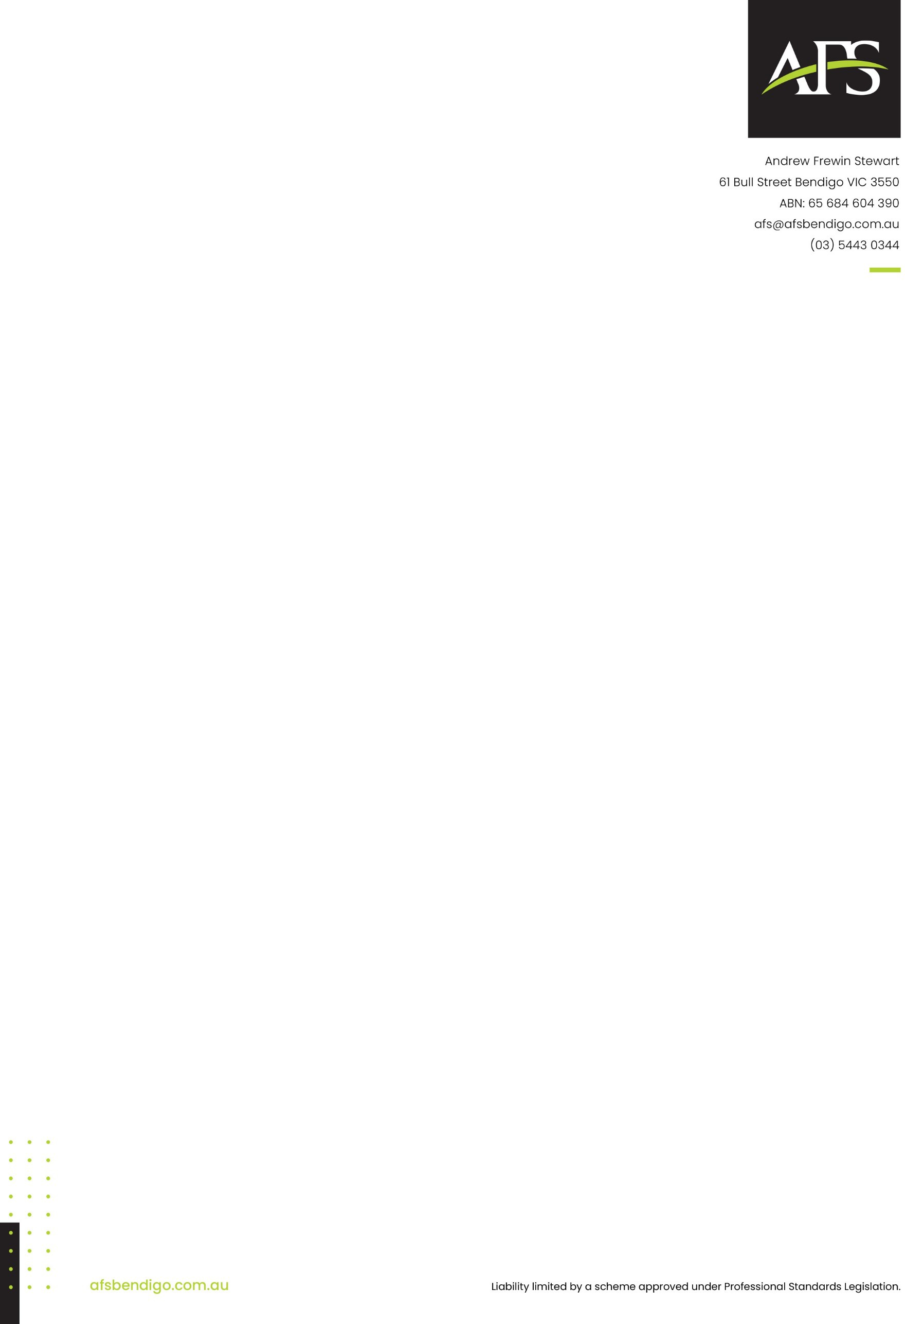

##### Independent Auditor’s Report to the Members of Rights Information and Advocacy Centre Inc

Report on the audit of the financial statements

Our opinion

In our opinion the accompanying financial report of Rights Information and Advocacy Centre Inc (the association) is in accordance with the *Australian Charities and Not-for-profits Commission Act 2012*, including:

1. giving a true and fair view of the association's financial position as at 30 June 2024 and of its performance for the year ended on that date, and
2. complying with Australian Accounting Standards - Simplified Disclosures.

What we have audited

The association’s financial report comprises the:

* + statement of financial position as at 30 June 2024
  + statement of profit or loss and other comprehensive income for the year then ended
  + statement of changes in equity for the year then ended
  + statement of cash flows for the year then ended
  + notes comprising a summary of significant accounting policies and other explanatory notes, and
  + the certification by members of the committee that the annual statements give a true and fair view of the financial position of the association.

Basis for opinion

We conducted our audit in accordance with Australian Auditing Standards. Our responsibilities under those standards are further described in the *Auditor’s Responsibilities for the Audit of the Financial Report* section of our report.

We believe that the audit evidence we have obtained is sufficient and appropriate to provide a basis for our audit opinion.

Independence

We are independent of the association in accordance with the auditor independence requirements of the Accounting Professional and Ethical Standards Board’s APES 110 *Code of Ethics for Professional Accountants* (the Code) that are relevant to our audit of the financial report in Australia. We have also fulfilled our other ethical responsibilities in accordance with the Code.



Other information

The association may prepare an annual report that may include the financial statements, committee’s report and declaration and our audit report (the financial report). The annual report may also include “other information” on the entity’s operations and financial results and financial position as set out in the financial report, typically in a Chairperson’s report and reports covering governance and other matters.

The committee members are responsible for the other information. An annual report has not been made available to us as of the date of this auditor's report.

Our opinion on the financial report does not cover the other information and accordingly we will not express any form of assurance conclusion thereon.

Our responsibility is to read the other information identified above when it becomes available and, in doing so, consider whether the other information is materially inconsistent with the financial report or our knowledge obtained in the audit, or otherwise appears to be materially misstated.

If we identify that a material inconsistency appears to exist when we read the annual report (or become aware that the other information appears to be materially misstated), we will discuss the matter with the committee members and where we believe that a material misstatement of the other information exists, we will request management to correct the other information.

Committee’s responsibility for the financial report

The committee of the association is responsible for the preparation of the financial report that gives a true and fair view in accordance with Australian Accounting Standards - Simplified Disclosures and the *Australian Charities and Not-for-profits Commission Act 2012* and for such controls as the committee determines is necessary to enable preparation of the financial report that is free from material misstatement, whether due to fraud or error.

In preparing the financial report, the committee is responsible for assessing the association’s ability to continue as a going concern, disclosing as applicable, matters related to going concern and using the going concern basis of accounting unless the committee either intend to liquidate the association or cease operations, or have no realistic alternative but to do so.

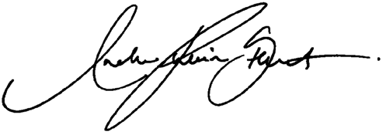

Auditor’s responsibility for the audit of the financial report

Our objectives are to obtain reasonable assurance about whether the financial report as a whole is free from material misstatement, whether due to fraud or error, and to issue an auditor’s report that includes our opinion. Reasonable assurance is a high level of assurance, but is not a guarantee that an audit conducted in accordance with the Australian Auditing Standards will always detect a material misstatement when it exists. Misstatement can arise from fraud or error and are considered material if, individually or in aggregate, they could reasonably be expected to influence the economic decisions of users taken on the basis of this financial report.

A further description of our responsibilities for the audit of the financial report is located at the Auditing and Assurance Standards Board website at: <https://www.auasb.gov.au/admin/file/content102/c3/ar1_2020.pdf> This description forms part of our auditor’s report

**Andrew Frewin Stewart Joshua Griffin**

61 Bull Street, Bendigo, 3550 **Lead Auditor**

Dated 19th September 2024