OUR CODE OF CONDUCT
Everyone that works at RIAC must follow this Code of Conduct. It is a rule book for RIAC workers to follow when they are working with you. This is to make sure you are safe and feel welcome and respected if you are a child, young person, adult, and have a Disability.
All RIAC Workers must:
 | Follow RIAC’s Policies and Procedures
 | Follow RIAC’s VISION and MISSION
 | Have a DUTY OF CARE towards people involved in our programs
 | Make sure our programs and offices are safe for children
 | Be fair, considerate, and honest
 | Treat ALL people with respect
 | Be a positive role model
 | Always be Professional
This Photo by Unknown Author is licensed under CC BY-NC-ND | Be Culturally SAFE and not discriminate or allow others to discriminate based on culture, race, or religion.
 | Make sure children with Disability are safe, involved and feel like they are heard
 | Report abuse of children to the CEO, police or Child Protection
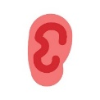 | Provide a service without abuse, neglect, harassment, or exploitation of people with Disability
 | Report any form of abuse of people with Disability
 | Do not sexually abuse or do wrong. Report any other workers, people with Disability, family members, carers or community members.
 | Show respect for different cultures
 | Respect the privacy of people with Disability and their families
 | Make sure you can understand what they are saying
 | Keep good professional boundaries
 | Never use power over a person with Disability or take advantage of them.
Encourage kids to have a say

Make any adjustments and give equal protection to all young people

Make sure all children and young people who can’t live at home, are lesbian, gay, bisexual, transgender and intersex people have their needs considered.
 | No person at RIAC shall:
 | Touch children that are not your own.
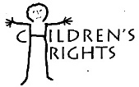 | Put children at risk of abuse.
 | Do things of a personal nature with someone else’s children - such as toileting or changing their clothes.
 | Have mature or adult discussions in front of children
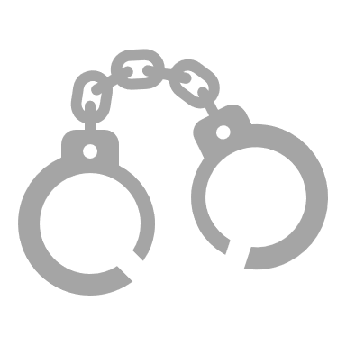 | Discriminate against anyone.
 | Have contact with a child (including online) or their family outside of RIAC- without the CEO’s knowledge and permission
 | Ignore any child abuse that has been reported or suspected
 | Shame, or put anyone down.
 | Do any activity that can physically or emotionally harm a child or adult
 | Be alone with a child or young person that is not your own.
 | Photograph or video a young person without their consent or their parent/guardian
@#$!!! | Use bad words in front of a child
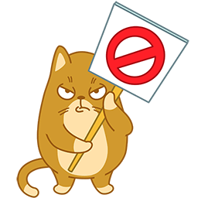 | Do anything that is not following RIAC’s Policies or Procedures

