Volunteer First Nations Advisory Group Member
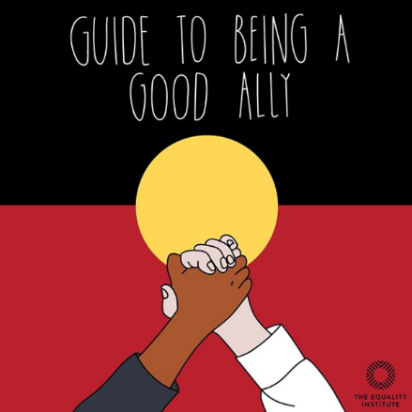

RIAC recognise a professional commitment as allies of Aboriginal and/or Torres Strait Islander People and communities.

RIAC supports that our First Nations peoples are seen in our country’s history and ensuring that Aboriginal and/or Torres Strait Islander voices are heard in any discussions about recognition and reconciliation.
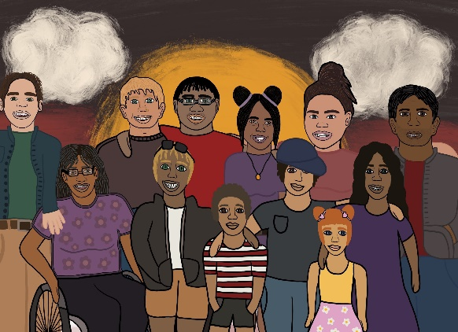
Our Aboriginal and/or Torres Strait Islander Advisory Group is a group of advocates and First Nations People with an interest in promoting the Human Rights of Aboriginal and/or Torres Strait Islander People with disability.

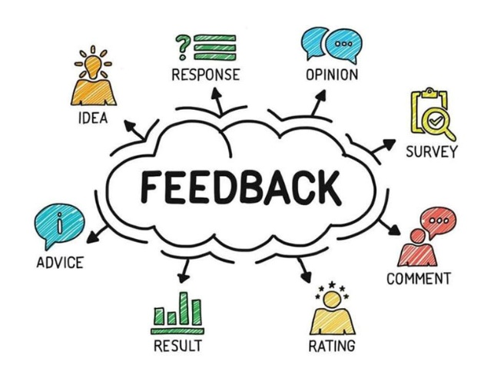
RIAC’s First Nations Advisory Group is an external group that guides RIAC, gives us advice and feedback on our Aboriginal and/or Torres Strait Islander resources, the way that we provide services and our policies and procedures. We would also love your expert advice on how we go about working with community and reconciliation.

Our First Nations Advisory Group will be made up of Aboriginal and/or Torres Strait Islander community members and allies from across RIAC’s funded areas within Victoria as well as RIAC’s staff members

The First Nations Advisory group will report to the Operations Manager.

What you need to do:
An induction workshop which will tell you about the role of the First Nations Advisory Group

Learn about RIAC’s Code of Conduct

Know our Policies and procedures

Be present at all the meetings of the First Nations Advisory Group and on time

Work with other members to achieve goals

Yarn about issues, share ideas, and come up with solutions of the group and give advice to RIAC

What you need to agree to, to apply?

hours per month for an online meeting of the Advisory Group
half days per year to meet in person

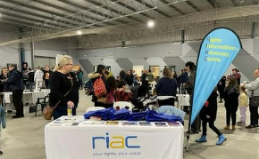
Assist and attend culturally significant events
Various other times to be negotiated where needed

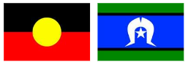
For this role, you must Identify as Aboriginal and/or Torres Strait Islander person or work closely with, have connections through personal networks or be an ally.

Have a disability either yourself, a family member or know community members with disability.

Have access to technology to come to online meetings

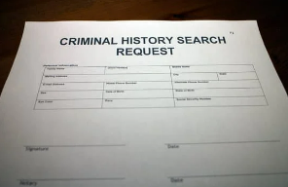
What sort of paperwork and checks do you need to do?

A National Police Records Check

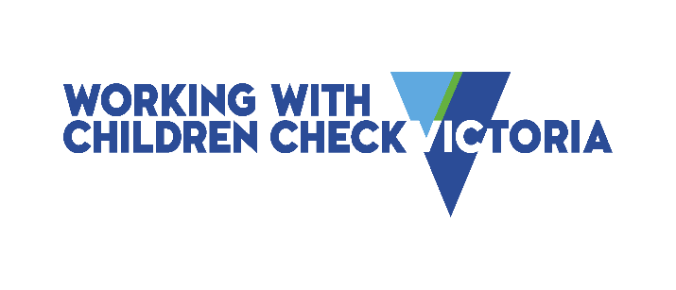
Working with children check

Some Statutory Declaration forms to be completed

You must show that you are fully vaccinated against COVID-19

Why should you join us?
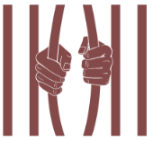

It supports freedom and choice

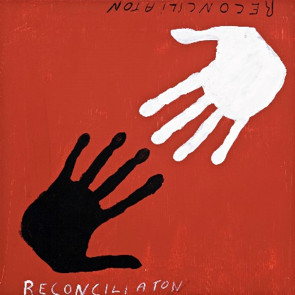

It supports reconciliation and strengthening connections to Country

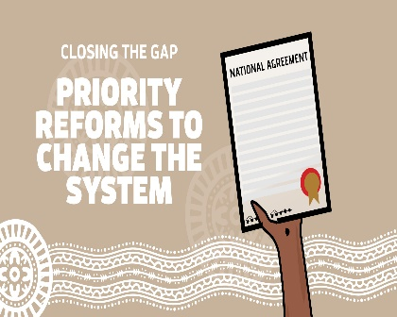

It Contributes to closing the gap

It builds allyship between Aboriginal and/or Torres Strait Islander services and non-indigenous services.

It allows First Nations people with disability to have a voice

