How to make a complaint about RIAC
Easy Read version
When you see the word ‘we’, it means the Rights Information and Advocacy Service, or RIAC.
You can find the other document on our website at www.riac.org.au

 | This guide tells you how to make a complaint if you are not happy with our services.
If you have asked for support from RIAC and you are not happy or do not feel that you were treated well, you have the right to complain.

For example, your advocate/worker made you feel bad, they did not do their job, or you do not think that they did the right thing.
 | You can call, write to, or email our Complaints person.
 | You can send an email to qam@riac.org.au
You can call or text us on
0491 208 110

 | You can write a letter and send this to PO Box 1763 Shepparton Vic 3630.
 | Our complaints person will then get back to you in 5 working days from receiving your complaint.
 | They will then look at your complaint and try to resolve it as quickly as they can.
 | If you are still not happy with us, you can take your complaint to an outside service who deals with complaints.
The Complaints Resolution and Referral Service can help you. You can call them on:
1800 880 052 (toll free).
Let them know that you are not happy with your service from RIAC and that you would like to make a complaint.

From July 1st 2020, you can also make a complaint about any worker to the Victorian Disability Worker Commission.

You can do this by filling out an online form at vdwc.vic.gov.au
You can call them on
1800 497 132
Write to them at GPO Box 181, Melbourne 3001.

They can arrange interpreters, including Auslan interpreters and arrange for you to meet face to face.

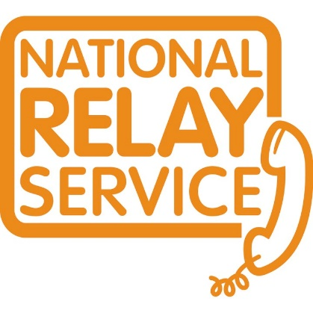 | Callers who are deaf or have a hearing or speech impairment can contact the National Relay Service (NRS) by calling  1800 555 677 then asking for 1800 880 052
 | If you do not speak English, you can use the Translating and Interpreting Service (TIS) by calling 13 14 50

Version 2 July 2021

